**↠PHANTOM Central Hub↞**

**Approved by: Senior Ranks from TR | Phantom**

Written by former Phantom MR, Adrián Martín Vázquez (A.K.A PacoAlmodovar).



■▬▬▬▬▬▬▬▬**【INDEX】**▬▬▬▬▬▬▬▬■

[#1] – REQUIREMENTS SPECIFICATION

[#1-1] - Project description

[#1-2] – Project goals

[#1-3] – Client Group Description

[#1-4] – Client Requirements

[#1-5] – Personas

[#1-6] – Research on Competitors

[#2] – PLANNING DEVELOPMENT

[#2-1] – Gantt chart

[#2-2] – Budget

[#3] – DESIGN

[#3-1] – Sketch

[#3-2] – Wireframe

[#3-3] – Colour Palette

[#3-4] – Typography

[#3-5] – Menu and navigation map

■▬▬▬▬▬▬▬▬**【/INDEX】**▬▬▬▬▬▬▬▬■

# **[#1] – REQUIREMENTS SPECIFICATION**

■▬▬▬▬▬▬▬▬▬▬▬▬▬▬▬▬▬▬▬▬▬▬■

## **[#1-1] - Project description**

**This project centralizes the interests and activities of the members of a Roleplay group on a single website, where they can find information about events, Unit of the Week, clips, combat strategies from training events, tutorials, and guides on becoming the stealthiest unit. In short, it’s a website that gathers all the information about this group, which is currently scattered across Discord chats, Roblox groups, and other social media platforms.**

**It will serve as an index for all types of information related to the roleplay and will be helpful for PHANTOM units (members). Additionally, it will include a link to view their uniforms and access their private training facility game (**[***HOLO***](https://www.roblox.com/games/6727543635/PHANTOM-Holo)**).**

■▬▬▬▬▬▬▬▬▬▬▬▬▬▬▬▬▬▬▬▬▬▬■

■

## **[#1-2] – Project goals**

**The project's purpose is to recruit more people, as the roleplay group desires increased activity. Therefore, the main goal is to boost the division's popularity, activity, and professionalism, as well as that of the game itself.**

* **Measures to be taken to achieve this:**

**To make this possible, the website will spread propaganda through ads on various platforms, as well as on the Home Page. Once a visitor with interest clicks on "visit our website," they will be directed to a page with a tactical or military design that aligns with the division's theme (Home Page ➜ About Us), drawing them into the website's topic.**

**Additionally, descriptions will be crafted professionally, and there will be a strong promotional effort to encourage visitors to join the group through videos, tutorials, guides, and forums. Notifications will pop up for those who register or log in to the website with the user registration system, and optional email adverts will be available for those who subscribe.**

**As mentioned, the primary focus will be on newcomers visiting the site. For this reason, the Home Page will include not only propaganda and ads, but also explanations of what Phantom is, the lore/history of the roleplay, promotional content, and reviews from other players about the game and the roleplay group.**

**To conclude, Phantom will add more sections where they can find events, Unit of the Week, clips, courses for new LUA developers in the Holo, links to the uniforms and games, etcetera.**

**With these measures and advertisement on different platforms, Phantom aims to attract an audience of 16 years old to 30 years old who enjoy stealth military content, who help increasing the** **average number of active players to a 15% more than it was in July which it was 100 players active on the Roleplay Game City-17, also Phantom wants to increase their community members too for more activity, from 25 members to 50 members at least, and more developers that want to work on their games for a reasonable price, they want to increase their developers from 3 that it is right now, to 10 and make a group of 5 working on the Roleplay games, and other 5 working on the HOLO.**

■▬▬▬▬▬▬▬▬▬▬▬▬▬▬▬▬▬▬▬▬▬▬■

■

## **[#1-3] – Client Group Description**

**PHANTOM is a divisional subgroup of a larger open community called “The Robine”. PHANTOM, however, is a private group that requires specific criteria to be met for recruitment or invitation. This group functions as a clan and participates in Roblox Combat League (RCL) tournaments, where they win prizes in money or Robux (the virtual currency from Roblox that can be converted to real money). They also engage in roleplay games within the main community, "The Robine". In these games (such as** [***City-17***](https://www.roblox.com/games/509062192/CORE-UPDATE-CITY-17)**,** [***City Reborn***](https://www.roblox.com/games/17835552135/C17-City-Reborn)**, and** [***Downtown RP***](https://www.roblox.com/games/125278189013070/Downtown-RP)**), PHANTOM operates as a Stealth Task Force, acting as "spies”. Also, there are a few of their members who are developers of one of these games and the private training facility of Phantom (HOLO). They program in LUA which is a language for sandbox games.**

**They also spread propaganda for both their divisional group (PHANTOM) and the main community (The Robine) to gain recognition within the broader Roblox community.**

**Their philosophy revolves around their motto: “Strike when they least expect it!” This applies not only for roleplay purposes but also as a strategy to maintain their community by seizing any opportunity that comes their way and turning it into reality. This is how they envision making this website a reality. And is how they wanted to prevail on the future.**

**[*This was all extracted from a meeting with the commander and owner of Phantom AdabWhen, and his Vice-commanders, tepigater and IamdeadX_XdaedmaI*]**

■▬▬▬▬▬▬▬▬▬▬▬▬▬▬▬▬▬▬▬▬▬▬■

■

## **[#1-4] – Client Requirements**

**Our SRs (Senior Ranks) from “The Robine” specify the content they want to add to the page. They have also provided me with some posts to start with. The following sections contain a variety of items that are listed:**

**>> HOME PAGE: This main page of the entire site will contain promotional material to encourage people to join the division, as well as explanations of what we do and other elements to attract you to our roleplay group. At the bottom of the page, there will be links to some of the sections you can explore within the site.**

**>> Announcements: This is an aside section that reports announcements posted by Senior Ranks through various channels regarding new regulations or updates for the community and the benefit of the Phantom group. This section is controlled exclusively by SRs and is divided into "versions." Additionally, announcements from the game developers will also be posted here.**

**>> Information: This is a footer section for visitors who may need more details before deciding to join. It serves as a reference for other documents where people can download or view additional information on external pages not directly related to the website. These documents explain important aspects of the group, such as rules, links to our game, and more.**

**>> Events: In this section, there will be events scheduled by Higher Ranks for both current and former PHANTOM units to help boost activity.**

**>> PEP (Phantom Entrance Program): This is a sub-page of the main events page. Here, visitors can apply to join the division. If selected, they will be redirected to another page where they must attend their first Tryout, which is a training event for newcomers. This event helps determine whether the applicant will be accepted or not.**

**>> PTEP (Phantom Tactician Entrance Program): This is a sub-page of the main events page, where units ranked as Tacticians will be selected to undergo a variety of tests to prove their worthiness for the new rank of GHOST, which is part of the MR (Medium Ranks).**

**>> Activity Sweeps: This page will showcase the best performer of the week, along with a section to congratulate the new units, which will be a subsection of this main section. It will also include a compilation of points earned by each unit each week, as well as those that have not met their quotas.**

**>> Promotions: This is a subsection of the main Activity Sweeps page. It will contain the names of the new units that have joined the division, as well as schedules for entry into the PEP.**

**>> WoF (Wall of Fame): This is a subsection of the main Activity Sweeps page. It will feature the unit, HR, or MR of the week, along with some promotional content to increase popularity.**

**>> Community: This page serves as a forum for any unit or visitor, allowing them to engage in discussions and create various types of group chats.**

**>> Polls: This is a subsection of the main Community page, where HRs, SRs, and Devs can create polls for all visitors or units to vote on as either YES or NO.**

**>> Request: This is a subsection of the main Community page, where units or visitors can submit requests for the improvement of the website or the entire group.**

**>> Tutorials: This is a subsection of the main Community page. As the name suggests, these are guides created by MR+ ranks to teach units and visitors how to be a good PHANTOM. This section is also helpful for newcomers to understand how the roleplay division works in-game.**

**>> Developers Media: This is a subsection of the main Community page. This one is a forum only made for developers, inside they divide the tasks to optimize work and create an endearing atmosphere between developers.**

**>> User Registration System: A way for a user to register inside a website and see more info about them, as at what time is an event and more data that a guest (not logged) can’t see.**

**In summary, the PHANTOM website covers a wide range of content to disseminate information about the roleplay group, including promotions, announcements, and community posts organized into sections and pages. Starting with the main one, the home page will feature promotional content, an explanation of what the PHANTOM group is, and links to other sections such as announcements, which will include updates from Senior Ranks (SRs), and an information section with important documents regarding group rules. Scheduled events will encourage activity among current and former units, while programs like the PEP and PTEP will assist current units and new members in integrating and ranking up. The site will also include a community forum for discussions, a request section for feedback, tutorials for newcomers and a developer’s forum, and a registration system that will work for the next idea that is explained below.**

* **IDEA: Personalized Recognition and Achievement System (PRAS): Personalized Recognition and Achievement System (PRAS): Implement a system that allows users to earn and display medals/badges based on their participation and contributions to the community, such as a Medal of Service or a Badge of Beta Tester for the Phantom | Holo game. These achievements could be showcased on an external page where users can see a list of their earned badges, with coloured badges (excluding negative colours) indicating what they have achieved. Additionally, there would be an option to share these badges on Twitter or other social media platforms to make the system more competitive.**

■▬▬▬▬▬▬▬▬▬▬▬▬▬▬▬▬▬▬▬▬▬▬■

■

## **[#1-5] – Personas**

***Next Page↠***

PERSONA nº1

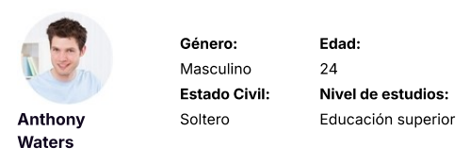

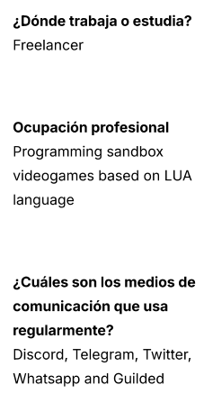 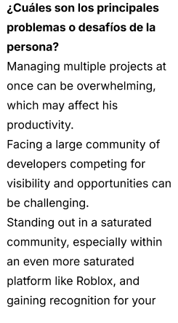

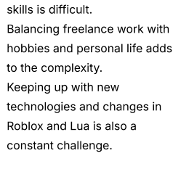

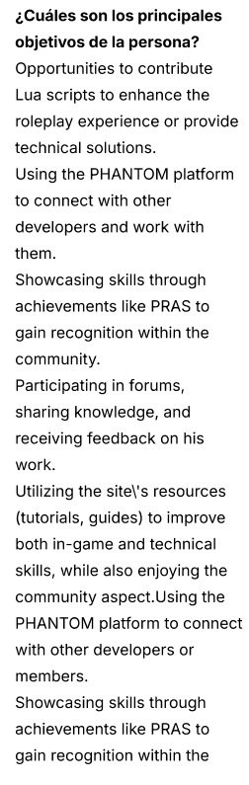  
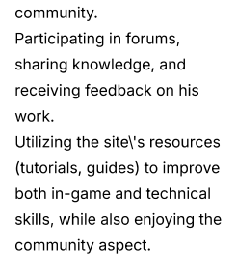

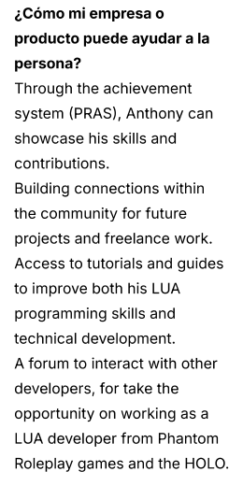



PERSONA nº2

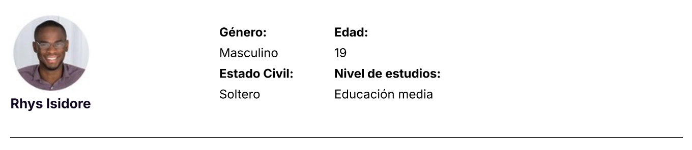

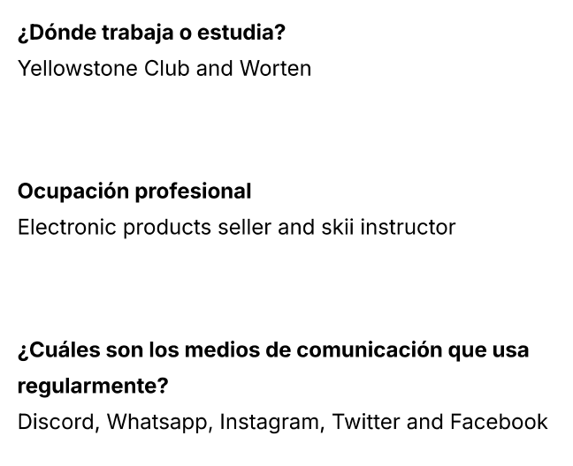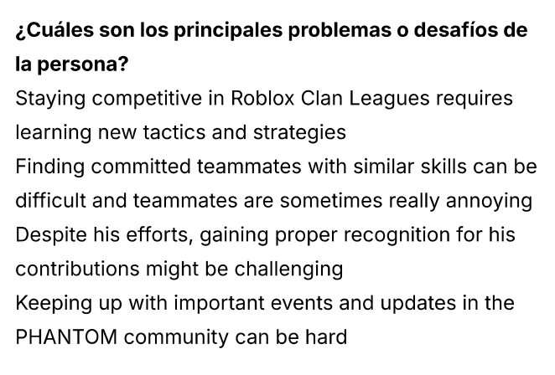

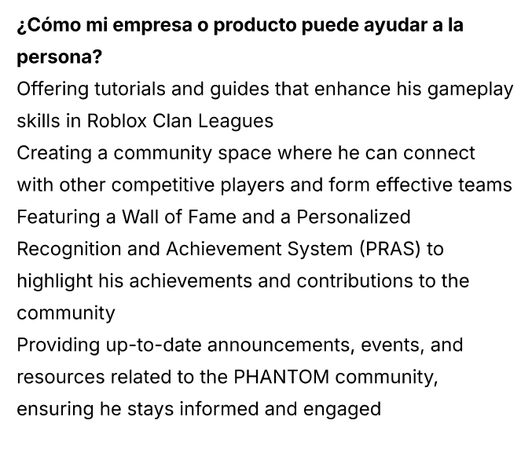  
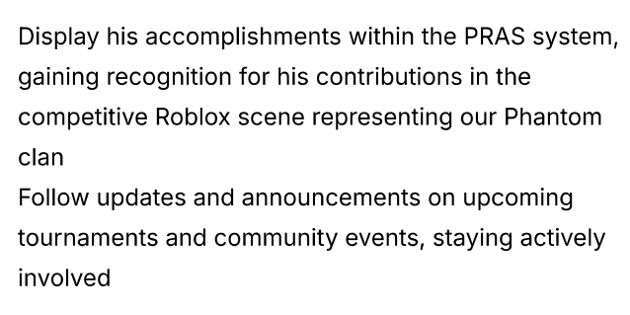

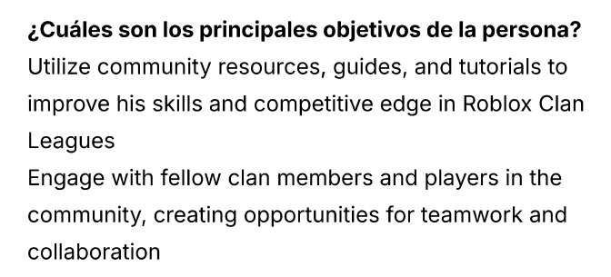

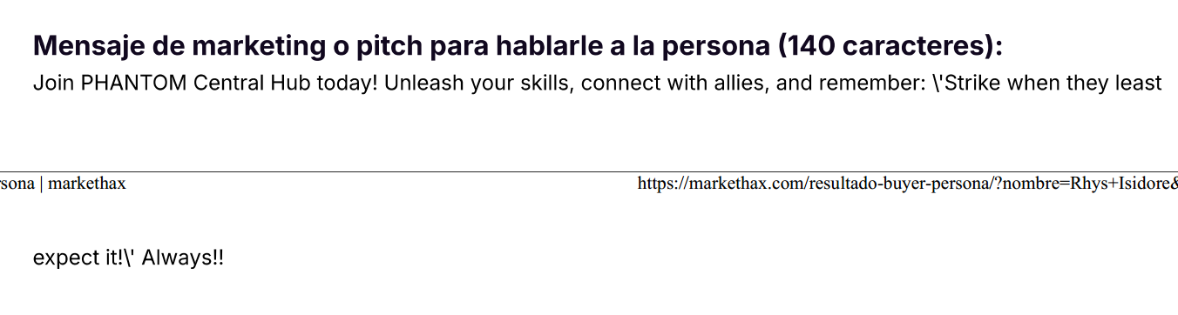

PERSONA nº3



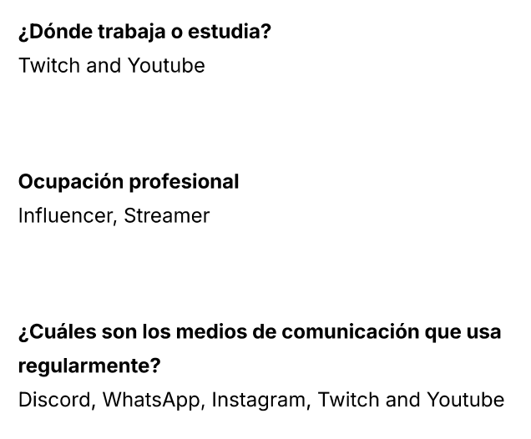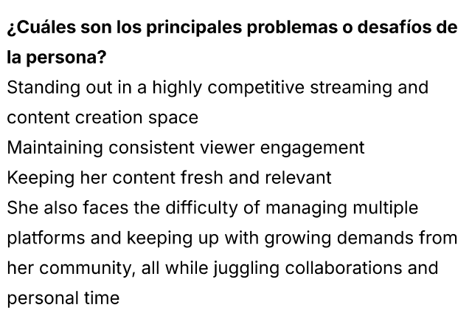

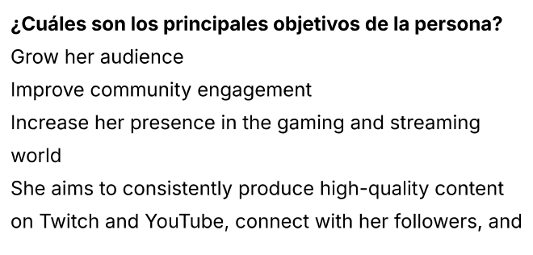  
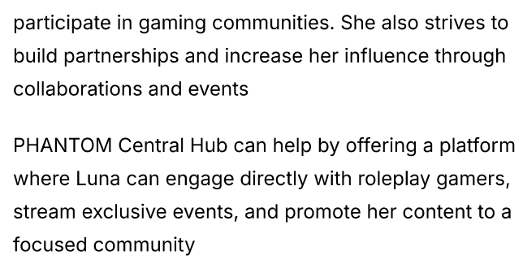

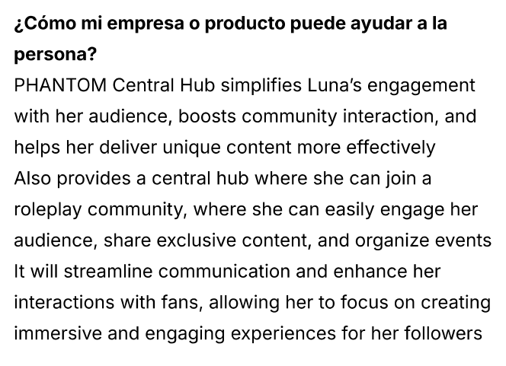

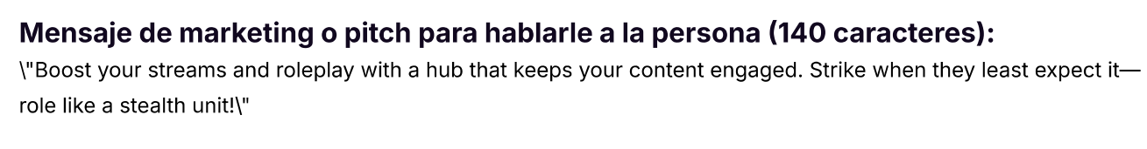

■▬▬▬▬▬▬▬▬▬▬▬▬▬▬▬▬▬▬▬▬▬▬■

■

## **[#1-6] – Research on Competitors**

**A thing Phantom liked about his competitors was the addition of a plugin to see the community channels, this could be useful for newcomers to see how each channel folder is aligned to not get lost inside the maze of channels. Also explaining what each channel is about.**

**As you can see below this is how our competitor has their information on TeamSpeak channels (same as Discord) on the aside section of the website. We can do the same and embed this information in the aside of the Phantom website**

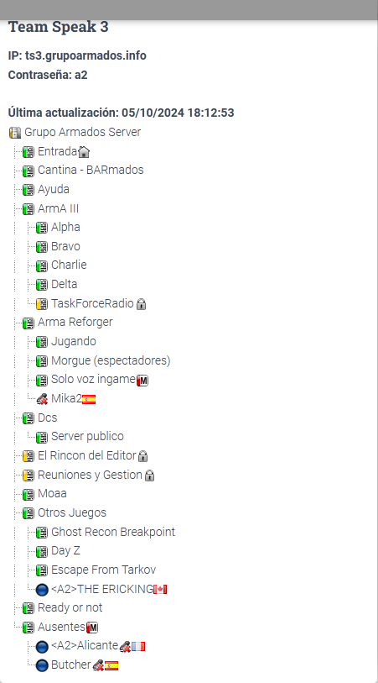

**Another thing we liked about our competitors is that they show a map of their game (Arma 3) with a marking point of where a base is located, with info about it**

**Here’s a picture from the website competitor:**

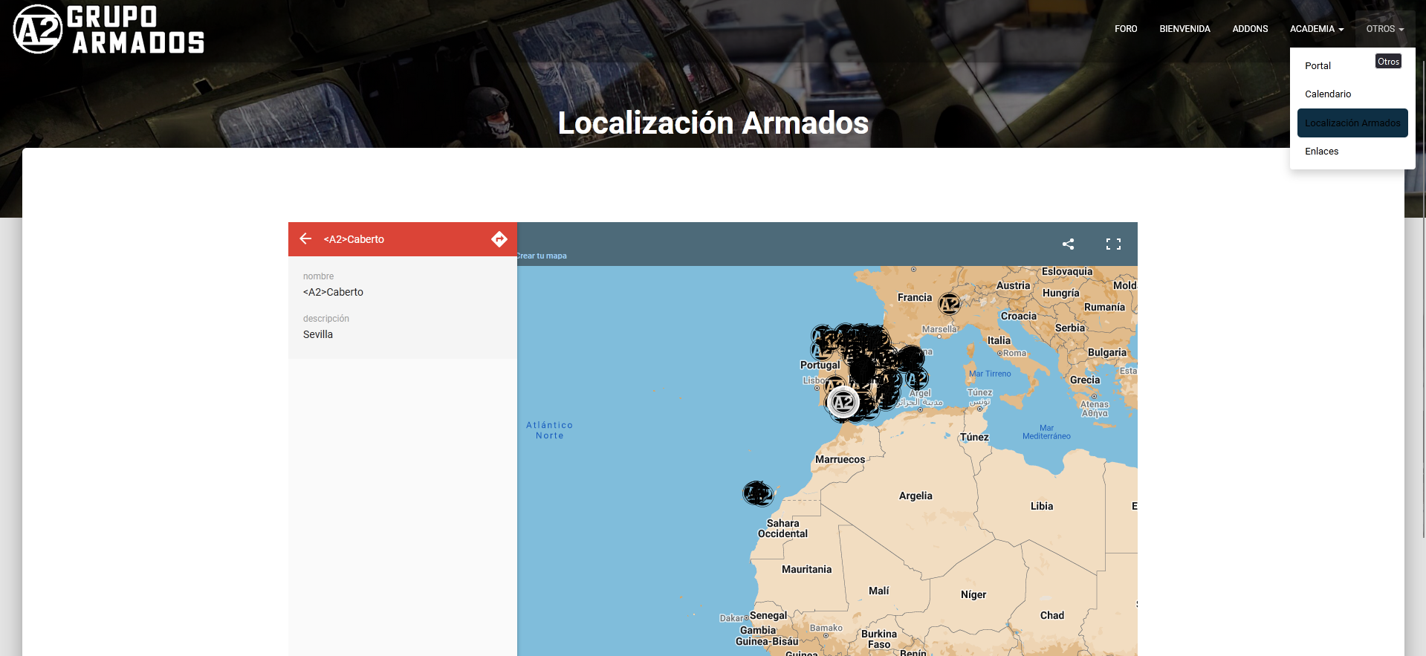

**Phantom wants this competitor’s idea on their website because it shows how the map is made, what each area is called and information about if you can go to the said area or not, or if it is dangerous, etcetera. Also has a map from the main Roleplay game The Robine City 17 that is shown below:**

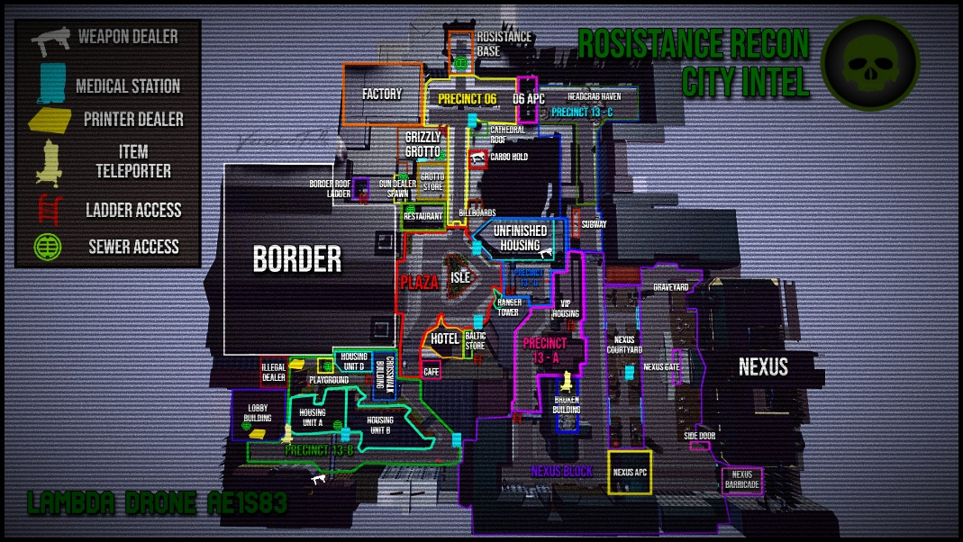

**We can add this map picture and make plugins to show information about every area on the about us page of the website.**

**The Discord channels integration can be done with a plugin on copy paste on the about us section and tutorials section of the website.**

■

■▬▬▬▬▬▬▬▬▬▬▬▬▬▬▬▬▬▬▬▬▬▬■

# **[#2] – PLANNING DEVELOPMENT**

■▬▬▬▬▬▬▬▬▬▬▬▬▬▬▬▬▬▬▬▬▬▬▬▬▬▬▬▬▬▬▬▬▬▬▬▬▬■

## **[#2-1] – Gantt chart**

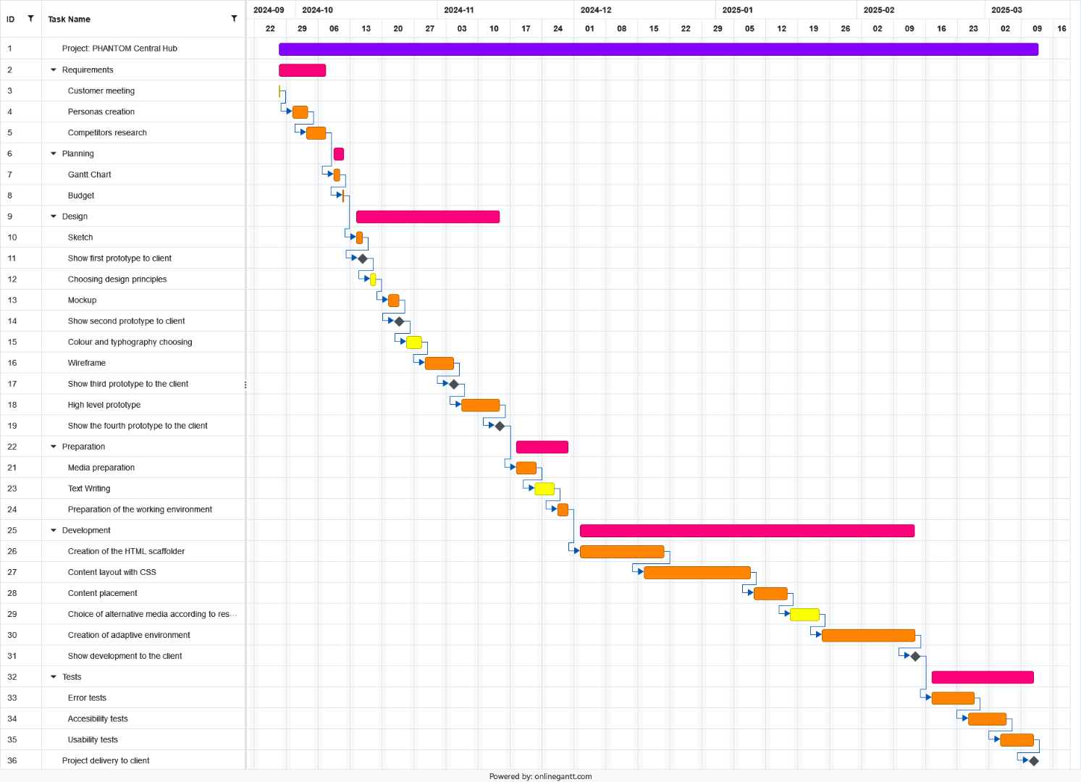**A task plan has been created, outlining the design, planning, development, and testing of the website project called “Phantom Central Hub” over a duration of 6 months, before its final delivery to the client. This diagram already considers the previous information discussed with the client, such as the initial meeting, the requirements gathering, and the current focus, which includes the budget and the Gantt chart. The latter is shown below:**

■▬▬▬▬▬▬▬▬▬▬▬▬▬▬▬▬▬▬▬▬▬▬■

■

## **[#2-2] – Budget**

**After carefully considering the client's requirements and goals for the Phantom Central Hub website during the meeting, a budget has been created in accordance with the client's needs. It includes a fixed price for the complete development and design of the website, as well as a bimonthly fee for ongoing maintenance. These prices have been deemed reasonable for both the client and the developer, ensuring the website's prosperity and proper care.**

|  |  |
| --- | --- |
| **OFFER** | **PRICE** |
| **Complete web design and development** | **16.500€** |
| **Website maintenance** | **2.062,5€** |
| **TOTAL** | **18.562,5€** |

**The fixed price for the project is calculated based on a rate of 600€ per week, with half a week costing 300€. As the Gantt chart shows, the minimum work duration will be 6 months (24th of September 2024 to 12th of March 2025).**

**The website maintenance cost is estimated to range from 1.375€ to 2.750€. The final price may vary depending on three main factors:**

* **Whether the website backups and database saves are up to date to avoid data loss.**
* **The extent to which the website requires frequent updates.**
* **The need for technical support to resolve website-related issues.**

**All these factors can increase the price up to 2.750€. However, if the issue arises from poor programming or a mistake made by the developer during website creation, a 50% discount will be applied, reducing the price to 1.375€ or lower.**

**In the meeting with the client, it was agreed that an initial payment of 63% of the fixed price would be made, which amounts to 6.105€. After the project is completed and fully paid for, the website maintenance payments will begin two months after the website is delivered to the client, and will continue bimonthly until further notice.**

■

■▬▬▬▬▬▬▬▬▬▬▬▬▬▬▬▬▬▬▬▬▬▬■

# **[#3] – DESIGN**

■▬▬▬▬▬▬▬▬▬▬▬▬▬▬▬▬▬▬▬▬▬▬■

## **[#3-1] – Sketch**

**The sketch of Phantom Central Hub is a rough visual plan that helps visualize the layout, hear the client opinions, improve the user experience, save time, and clarify the content hierarchy. It serves as a “blueprint” for the design and development process, allowing for early feedback and adjustments before choosing design principles and creating the mockup.**

**Now, the sketches for this website will be described below.**

1. **LANDING PAGE:**

**This first sketch has a simple design to attract new users.**

**The page includes a predefined header with the website's logo and title, Log In and Register buttons in a dropdown menu, four buttons to navigate to other pages, and a footer with a certification mark from the Senior Ranks of Robine to make the page official, links to the About Us page, additional information (via a Google Drive link), and up to four social media buttons.**

**The main section features a title inviting users to join, options to log in or register, and a description explaining the PRAS system to help new users understand it.**

1. **HOME PAGE:**

**This next sketch is the home page after logging into Phantom Central Hub.**

**This page features a predefined header and footer (like the rest of the pages). The account is logged in, showing the profile picture, name, additional information about the account, and a link to the PRAS system to check out achievements, all in the dropdown menu.**

**In the main section, there is an announcements/news area with a background image (currently drawings). Below there are the announcements sorted by version, each accompanied by images, and a call to action at the end of each announcement saying, 'JOIN US NOW!' with a link button to the PEP or events page.**

1. **EVENTS MENU:**
   1. **ACTIVES:**

**In this Events page, all the events currently taking place can be seen.**

**It features the predefined header and footer. In the main section, there is the title of the page along with a description stating that this is the active events page. Below, the events are displayed with the host’s name and profile picture, the event name, an 'ON AIR' text with red glowing circles, and a JOIN button directing you to the game.**

* 1. **SCHEDULED:**

**This page is the same as the one from before but is designed for events that are going to occur in the future.**

**It features the predefined header and footer. The changes in the main section include a description under the title stating that this is the scheduled events page. Instead of the 'ON AIR' text, there is a date for the event, and instead of the JOIN button, there is a Reminder button to receive notifications about the event directly to your email.**

1. **COMMUNITY MENU:**
   1. **POLLS:**

**In this subpage of the community, users can ask the community what they would like in different contexts.**

**It features a predefined header and footer. In the main section, there is the title of the page with images (currently drawings) displayed in the background. Below, there are user polls with their names and profile pictures shown, asking the community various questions. Each poll includes a valid checkmark and a negative checkmark, along with a number indicating how many people clicked on each option. Some polls also allow for inserted images.**

* 1. **TUTORIALS:**

**In this community subpage, there are tutorials and guides related to the game and the roleplay aspect.**

**It features a predefined header and footer. In the main section, there is the title of the page with images (currently drawings) displayed in the background. Below, the tutorials are sorted by STEPS, which is a thoughtful approach to encourage users to read all the tutorials to become great members of Phantom and skilled players of the game. Each Tutorial Step includes a video explanation.**

* 1. **DEV PAGE:**

**This page is exclusively for developers to collaborate on maintaining Phantom and developing new features, as well as helping with bugs, glitches, and various issues, fixing them and receiving feedback and rewards (monetary) for their efforts.**

**It features a predefined header and footer. In the main section, there is the title of the page. Below, there are two dropdowns for a developer’s chat and a multimedia section where developers can upload their work (links, images, videos, files, etc.), these two dropdowns are shown on the sketches. There is also a report and feedback section for developers to view issues that need to be fixed, which may be technical or related to their games.**

* 1. **USER PAGE:**

**This is the User page, which also contains communications for the chats you own and the friends you have earned. This page is designed to manage your user experience and includes the phrase 'be a gossip with your mates,' as the website developers chose to term it. It also displays the PRAS achievements for you to view.**

**It features a predefined header and footer. In the main section, there is the title of the page with images (currently drawings) displayed in the background. Below, there are two dropdowns for chats and friends, which can indicate whether they are online or offline, these two dropdowns are shown on the sketches.**

**Additionally, there is a profile section that includes the banner or background colour/image of the profile, the profile picture, the nickname, the email for contact, an about text for the user to describe themselves, and an edit button to rewrite all the information about the user. Below this, there is the PRAS achievements section that shows the awards you have earned along the way as a user on the page, along with the percentage of users who own each award and the name of each award. If you click on a locked award, a pop-up will display instructions on how to unlock it; if it’s locked, you cannot see the percentage of people who own it or its name. There is also a share button to share your progress with your favourite friends.**

1. **ACTIVITY SWEEPS:**

**This last page is designed for users who want to know their roleplay points like Recommendation Points (RP) for promotion, as well as for those who have failed and may be subject to punishment. There is also a Wall of Fame featuring images (drawings) for the ranking positions of individuals who have patrolled the most, excelled in shooting, or are recognized as the best in the community, among other roleplay-related surplus.**

**It features a predefined header and footer. In the main section, there is the title of the page with images (currently drawings) displayed in the background. Below, there is a chart for the quota of each unit/user of Phantom (this could be an Excel import). Below that, there is the Wall of Fame section with the rankings mentioned earlier.**

1. **ABOUT US:**

**And last but not least, the About Us page showcases the story, the collaborators, and the creators of this roleplay subgroup of Robine. It features a trailer for the roleplay, as well as a map (that didn’t fit entirely) of the main game that highlights each area. When you click on an area, a pop-up should display the area name, an explanation, and images or gameplay demonstrations. There is also Discord integration, similar to what is found in the tutorials section, although it didn't fit into the sketch. Nonetheless, it will be included on the website.**

**It features a predefined header and footer. In the main section, there is a styled title of the page with images (currently drawings) displayed in the background. Below, you will find the elements in the same order as stated before.**

**After the descriptions of each sketch, the images of the mentioned sketches are shown on the following pages:**

**1:**

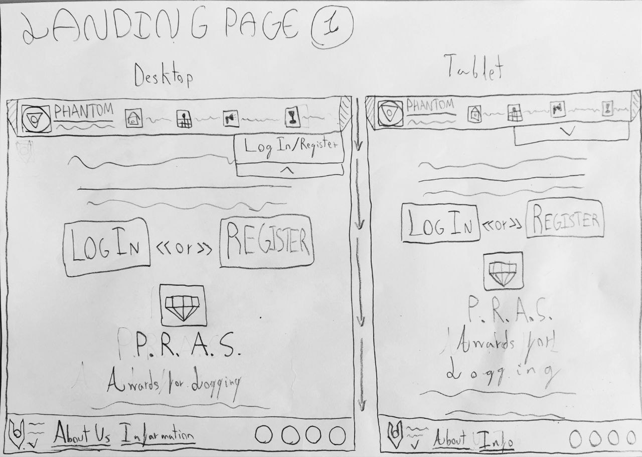

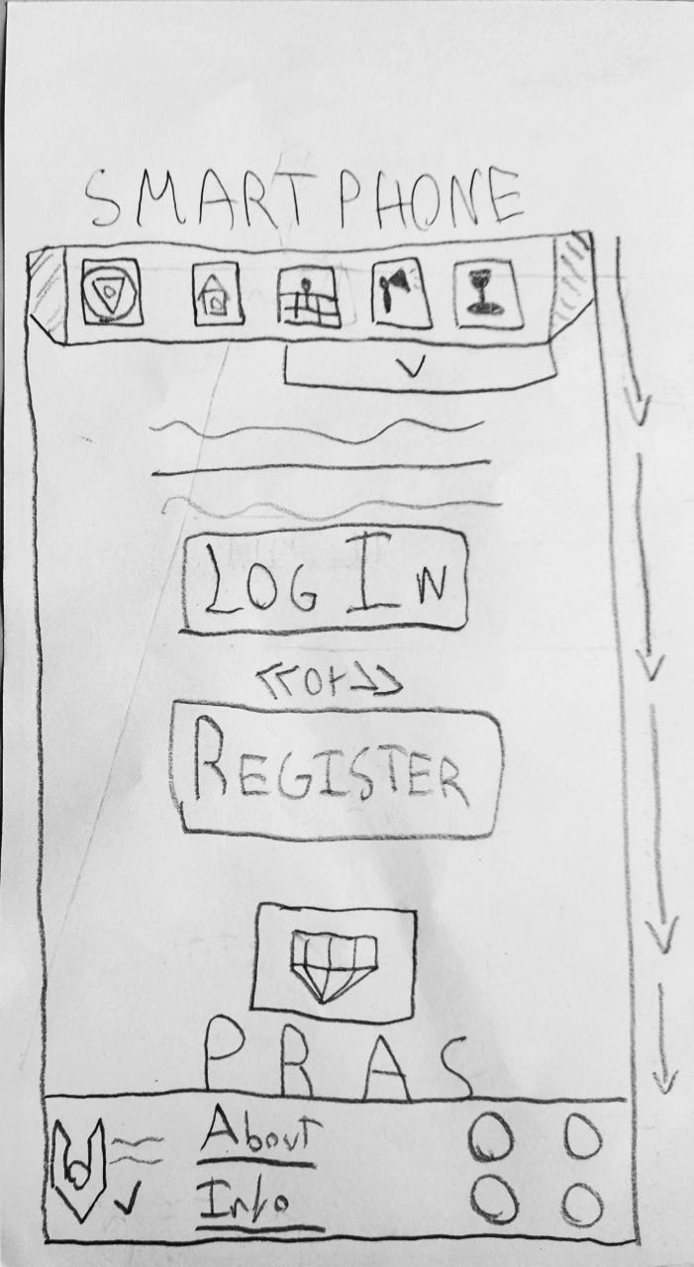

**2:**

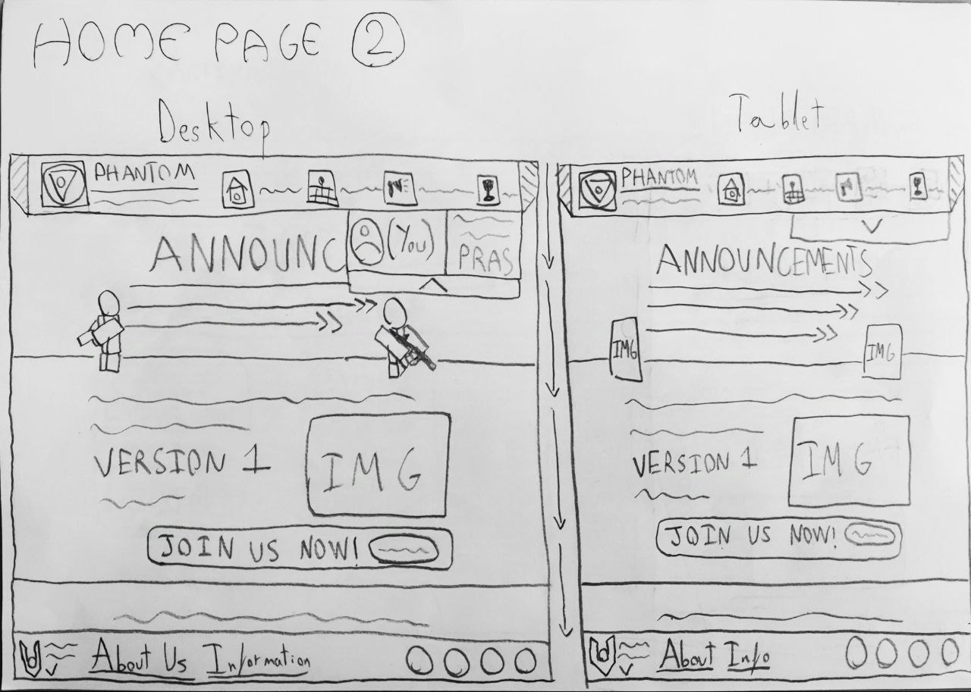

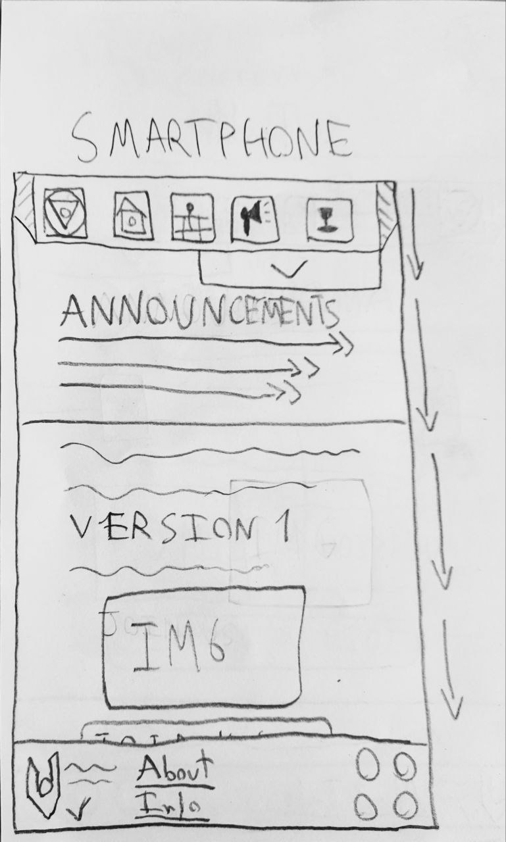

**3.1 (3):**

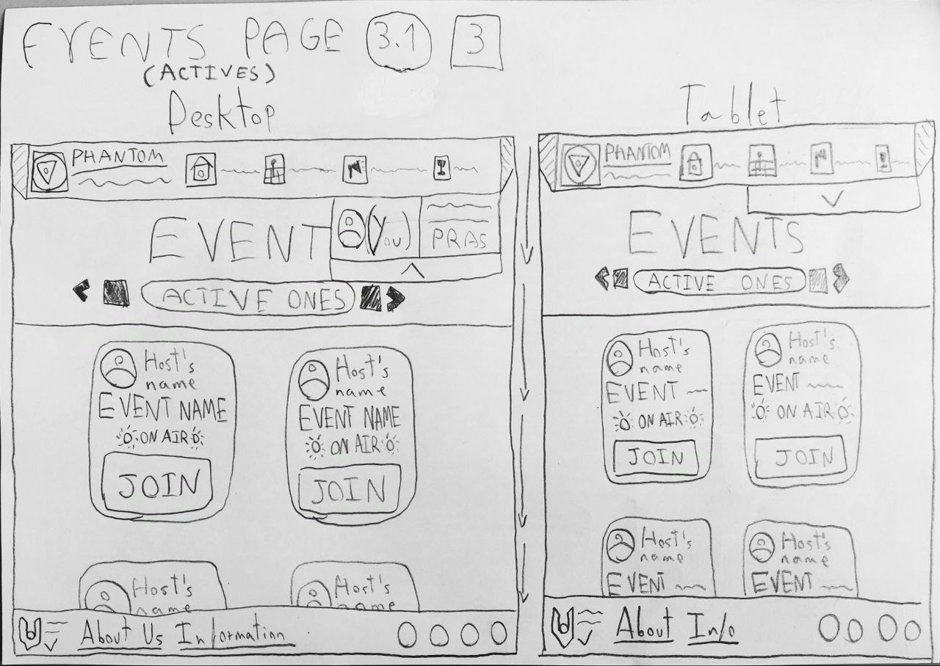

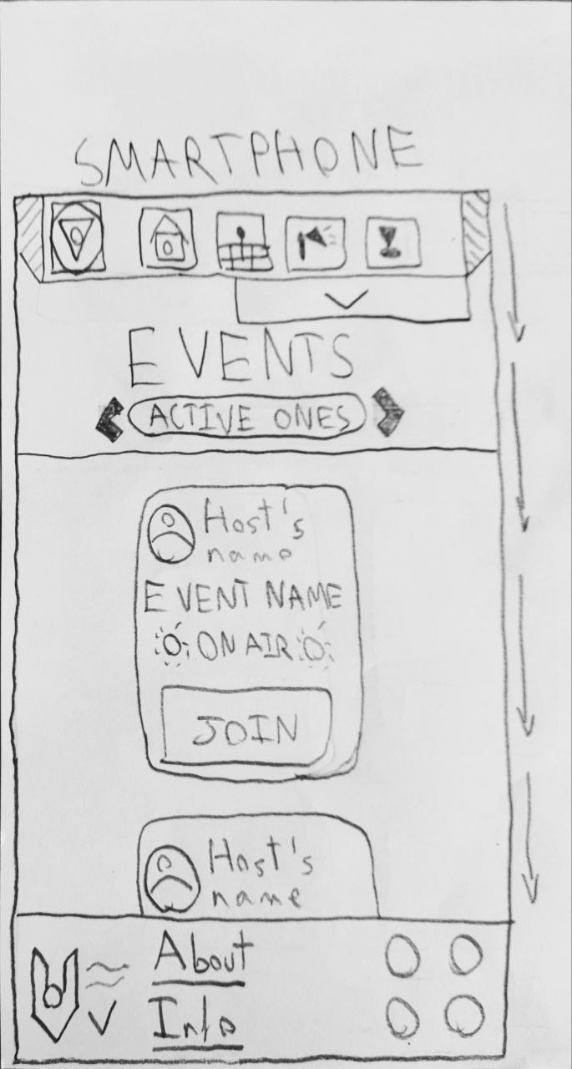

**3.2 (3):**

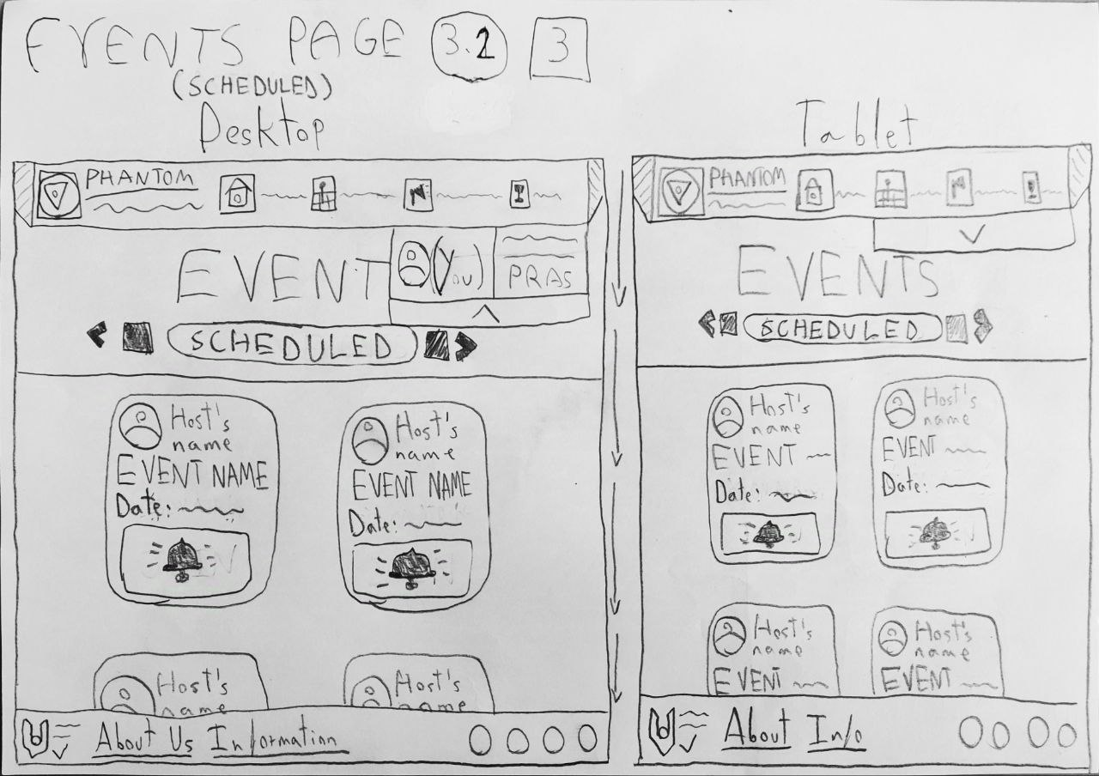

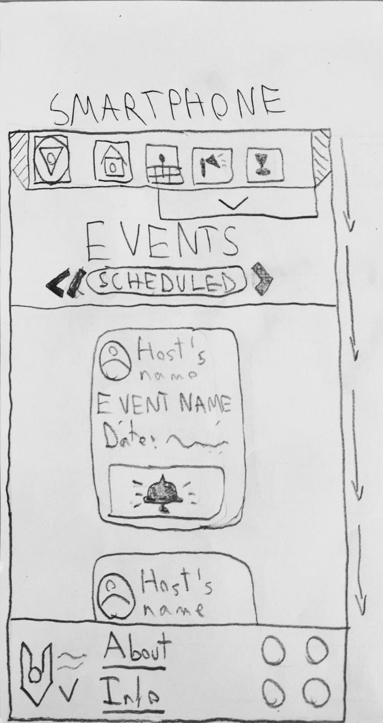

**4.1:**

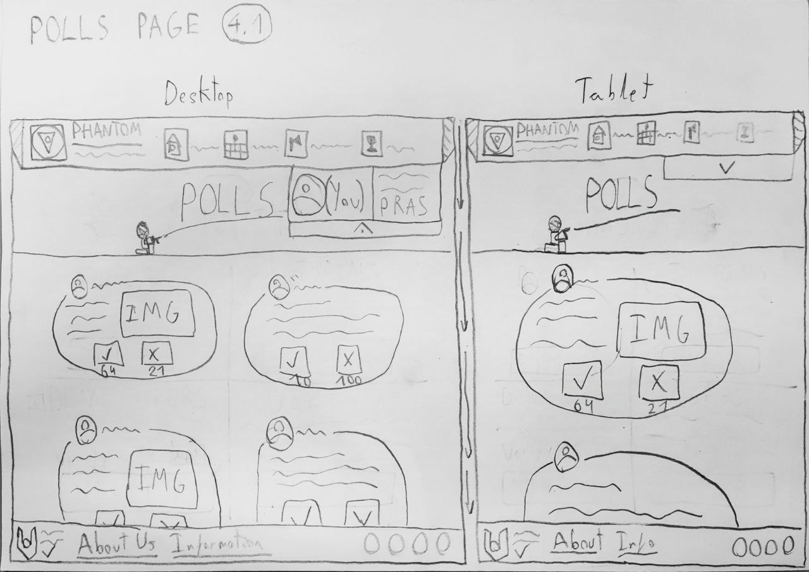

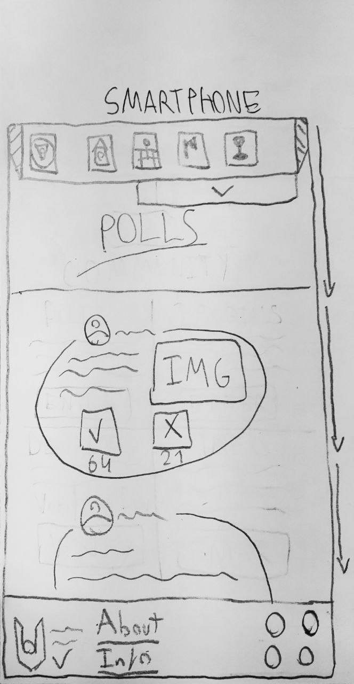

**4.2:**

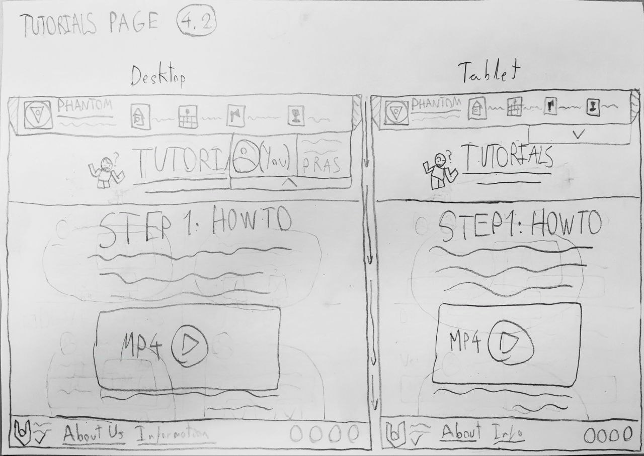

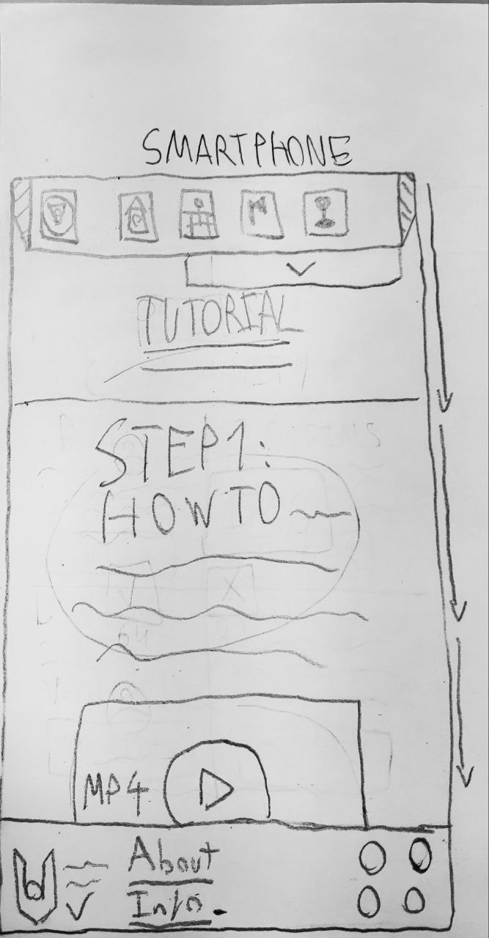

**4.3:**

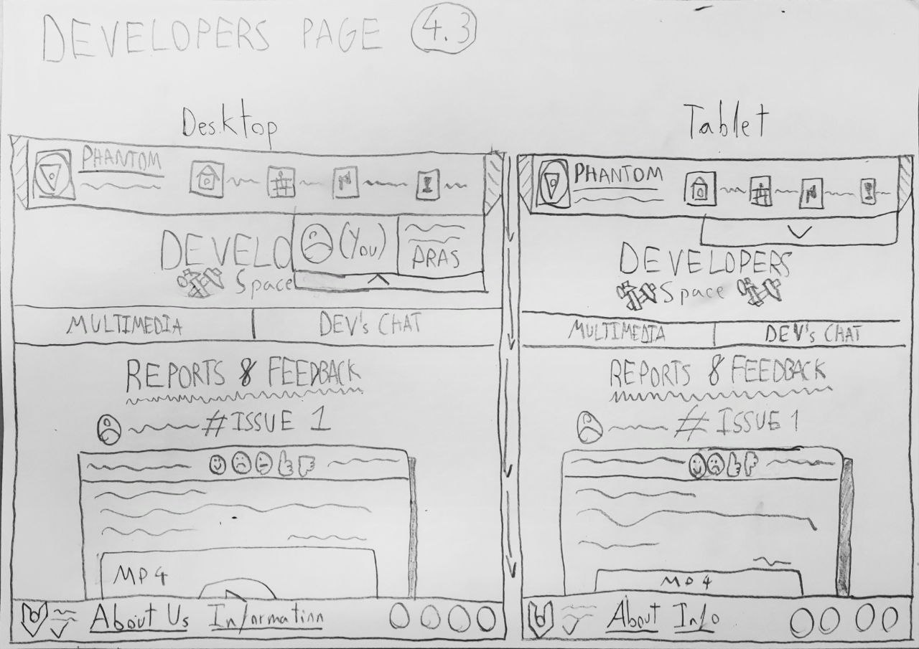

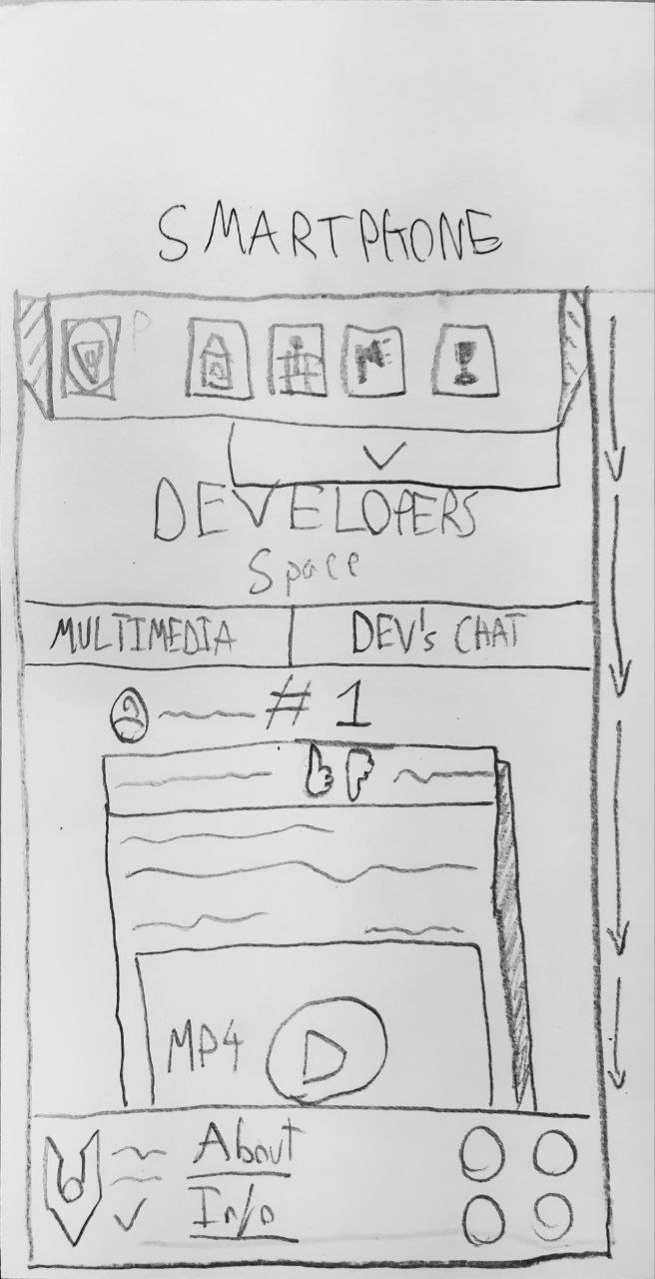

**4.3 (Multimedia):**

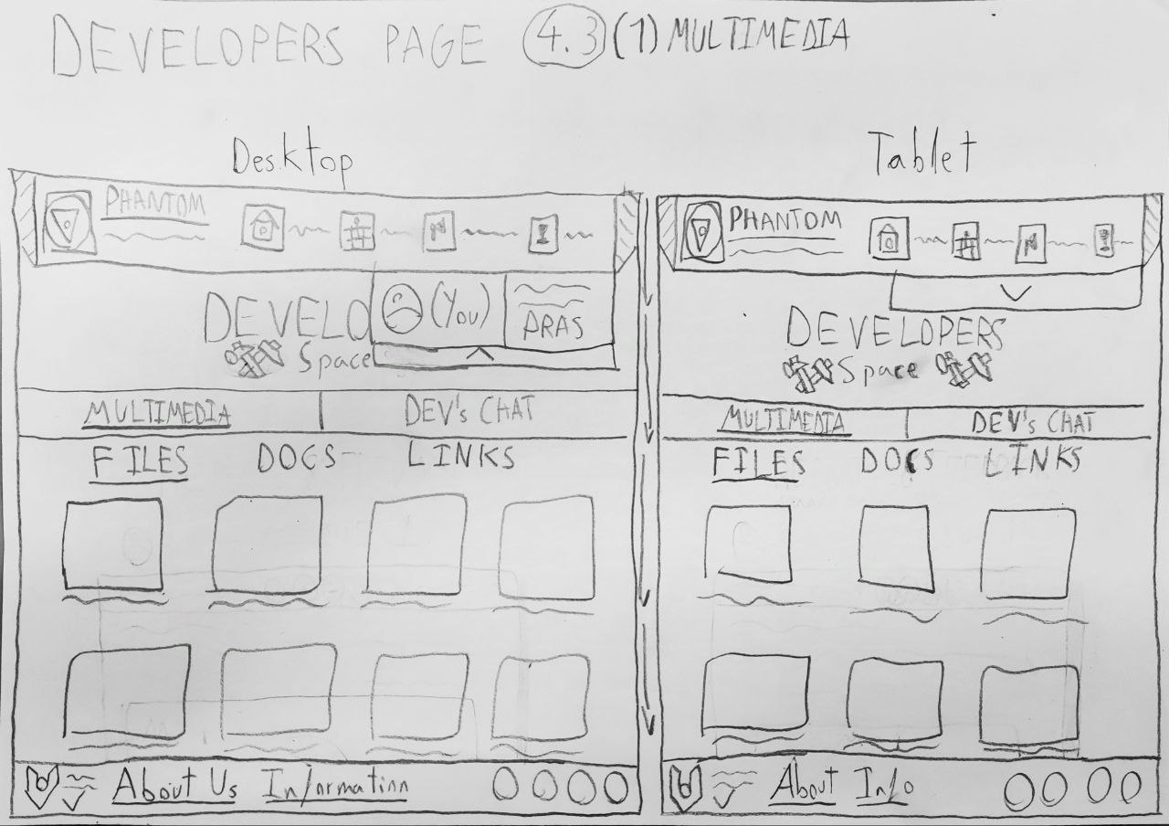

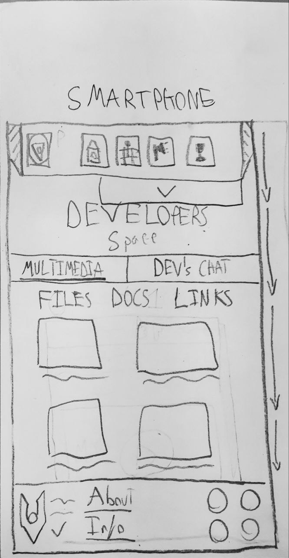

**4.3 (Chat):**

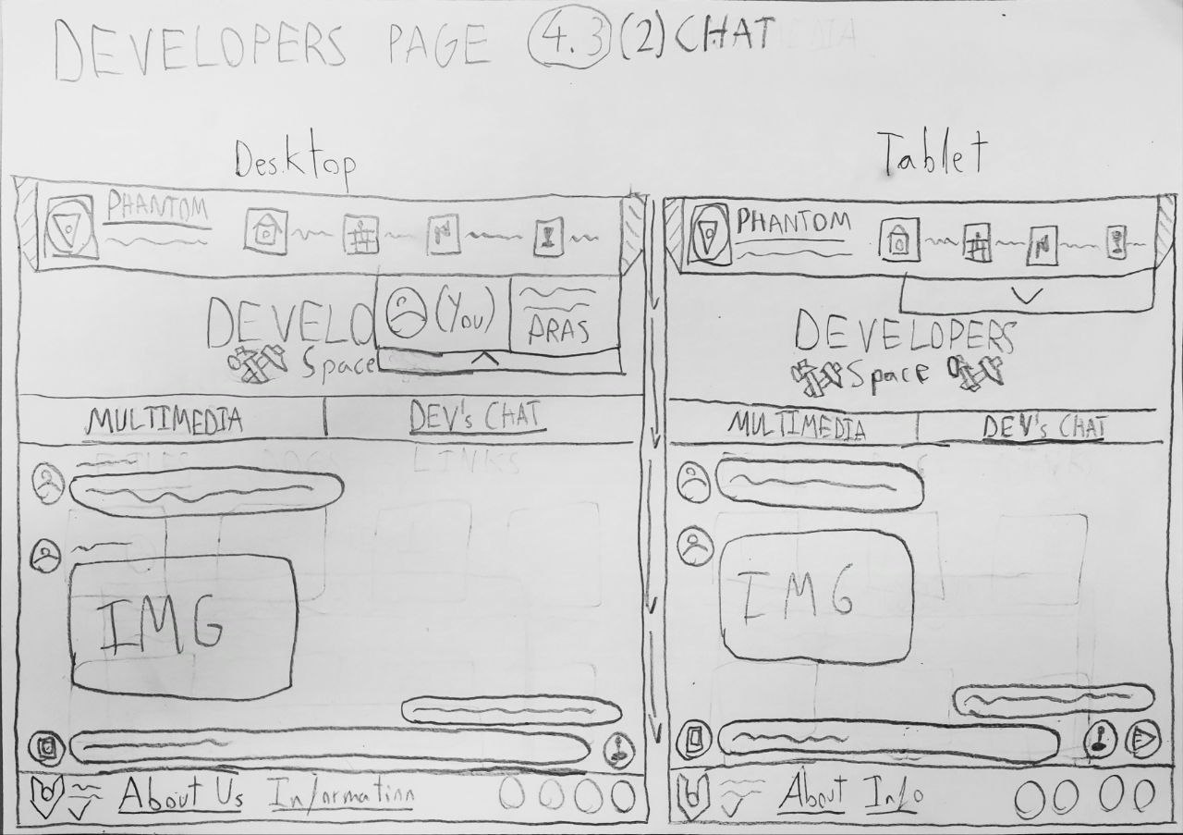

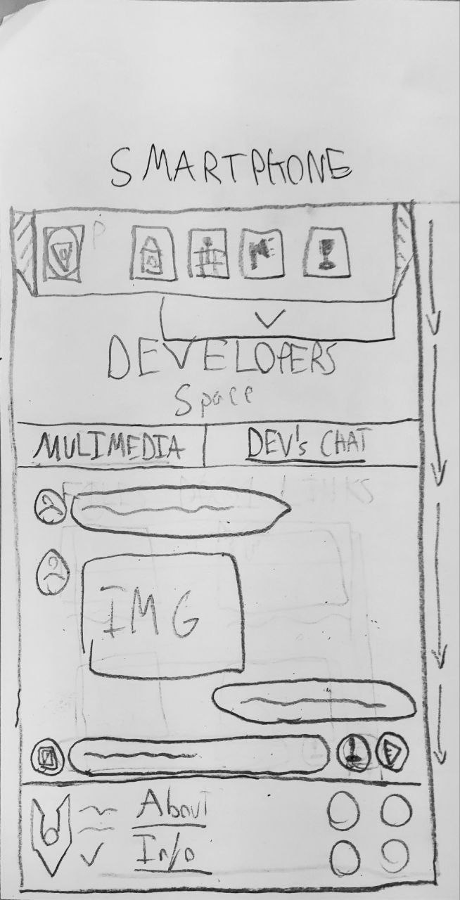

**4.4:**

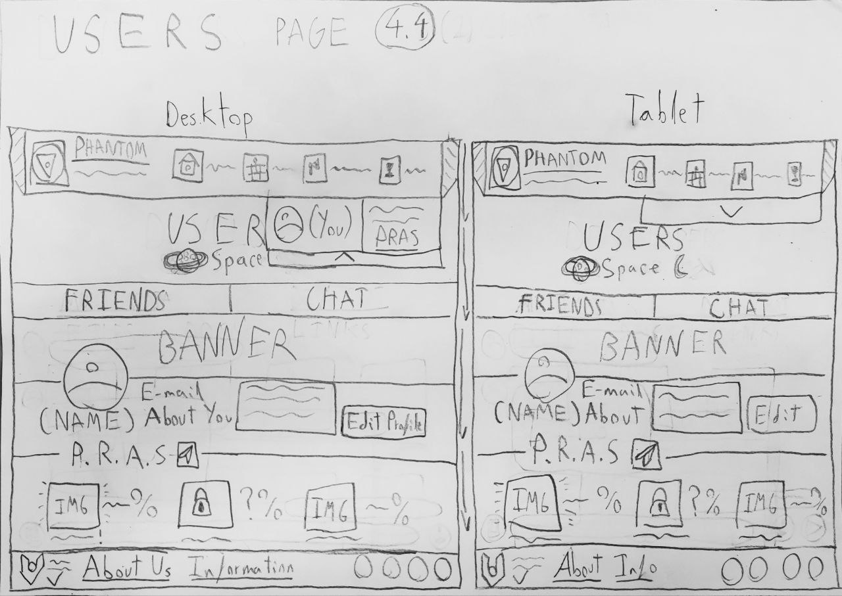

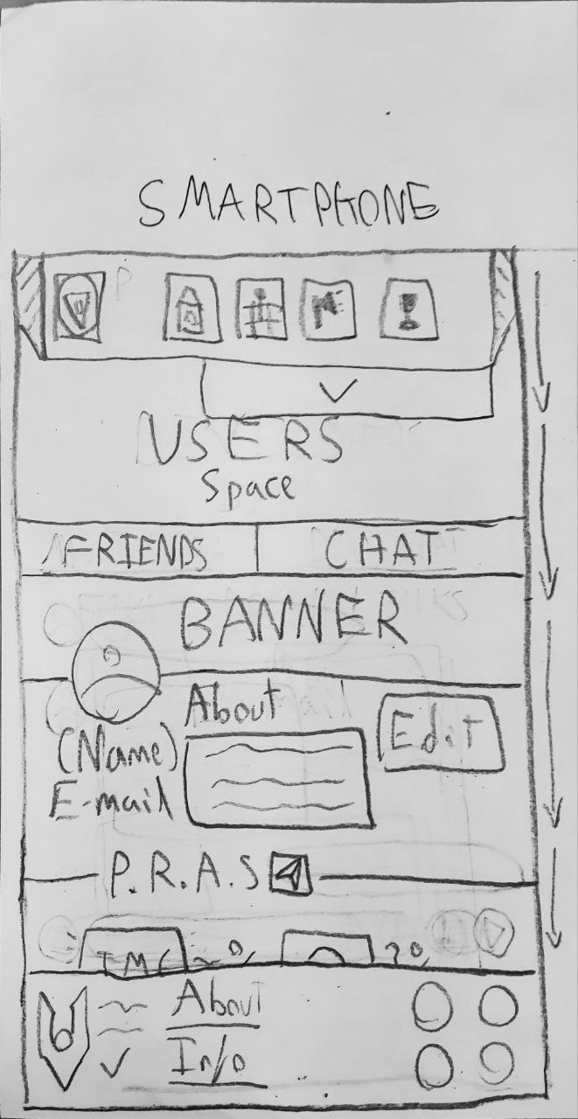

**4.4 (Friends):**

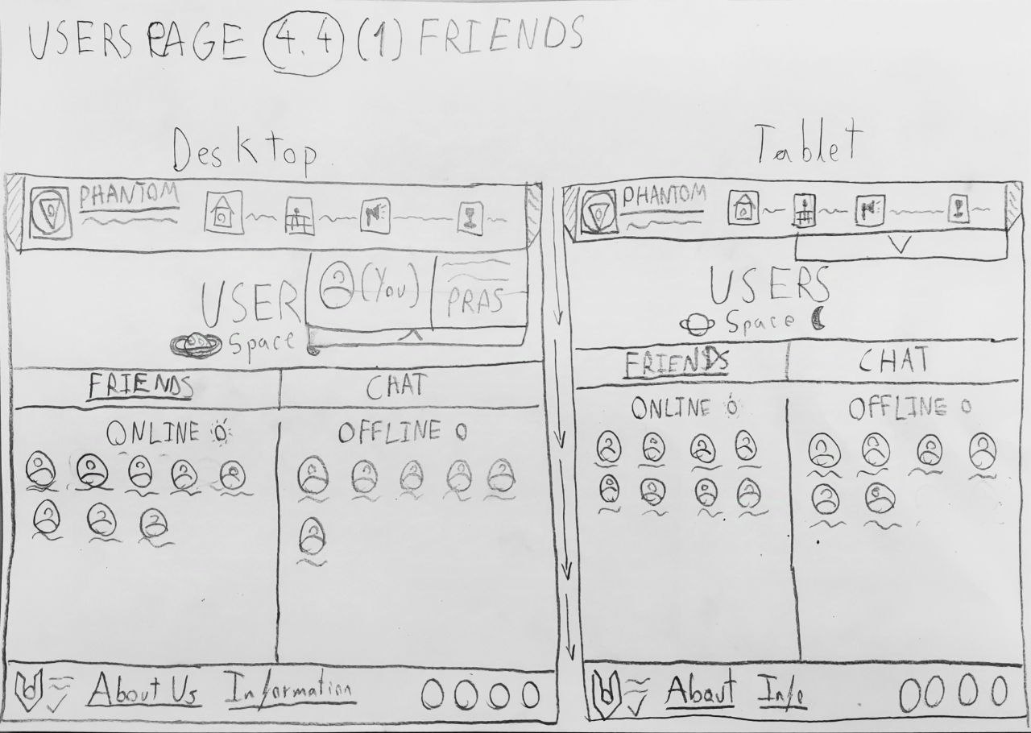

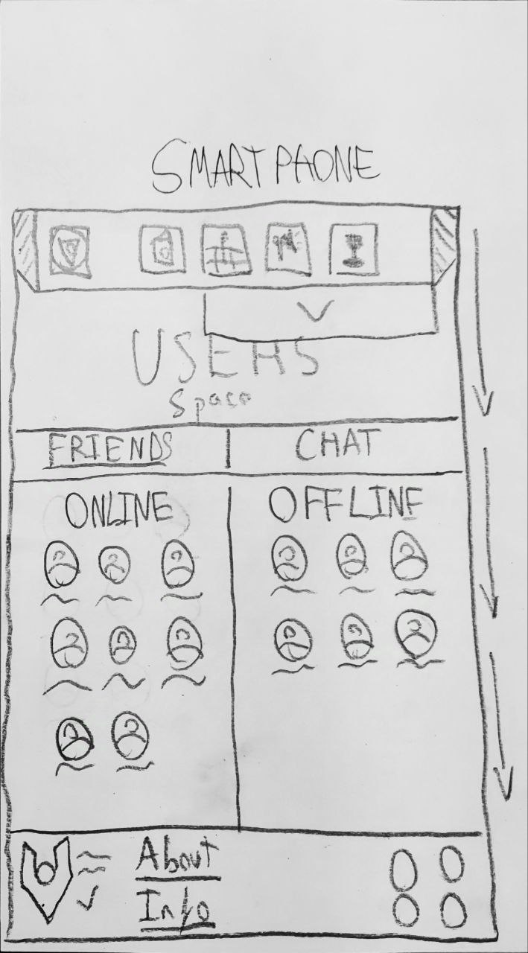

**4.4 (Chat):**

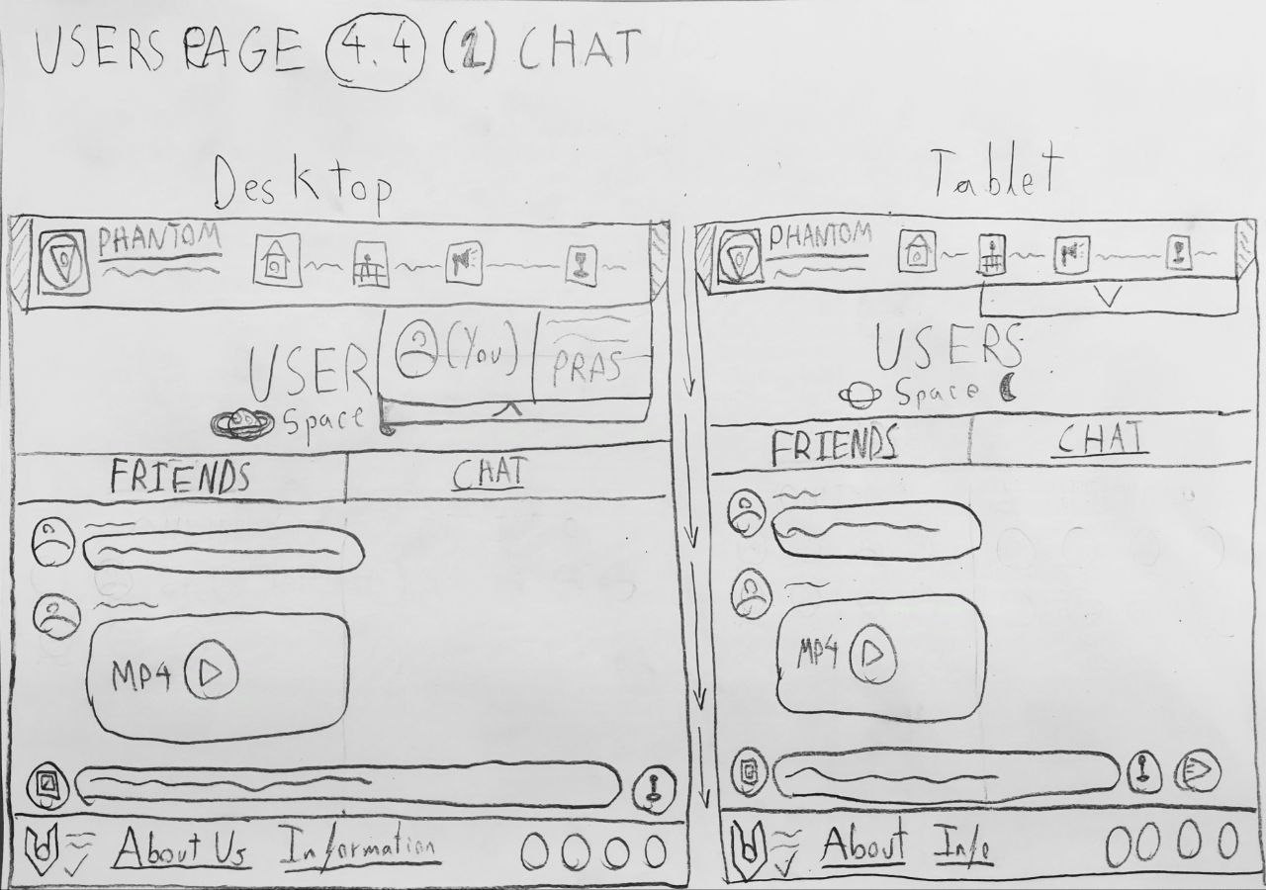

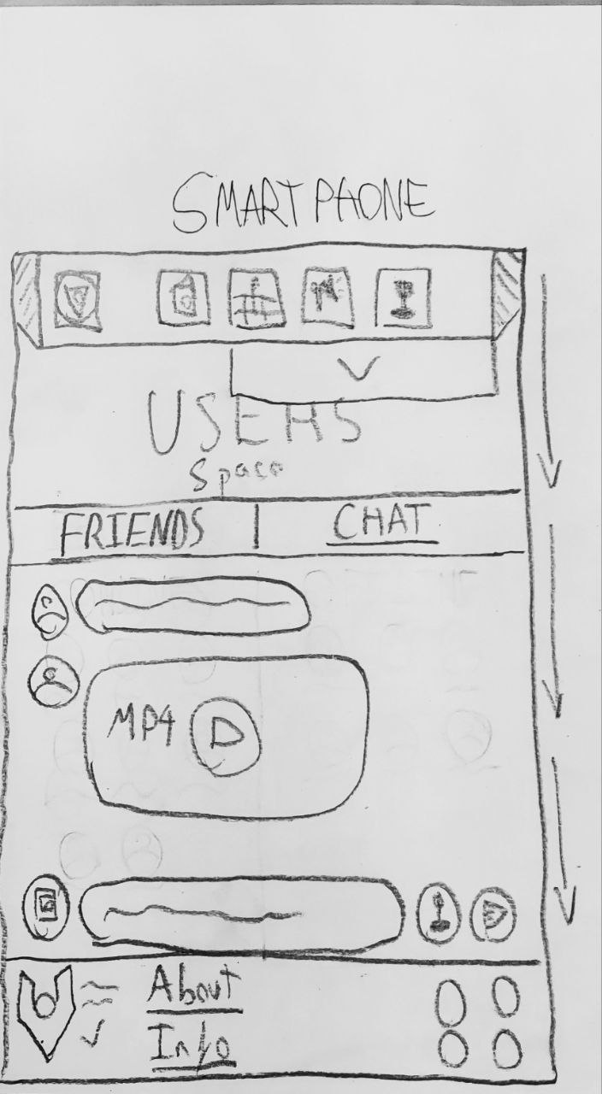

**5:**

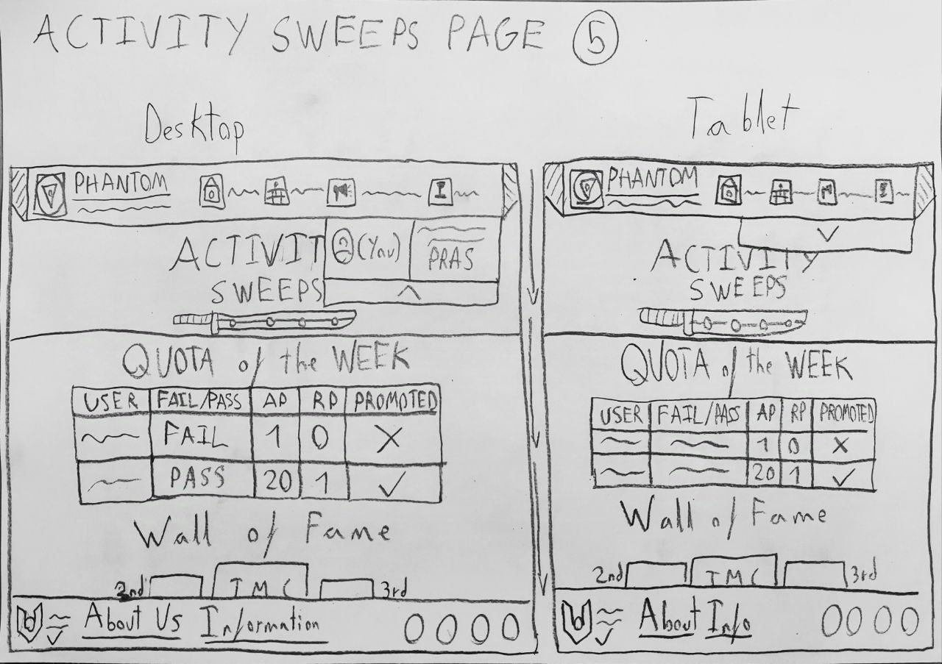

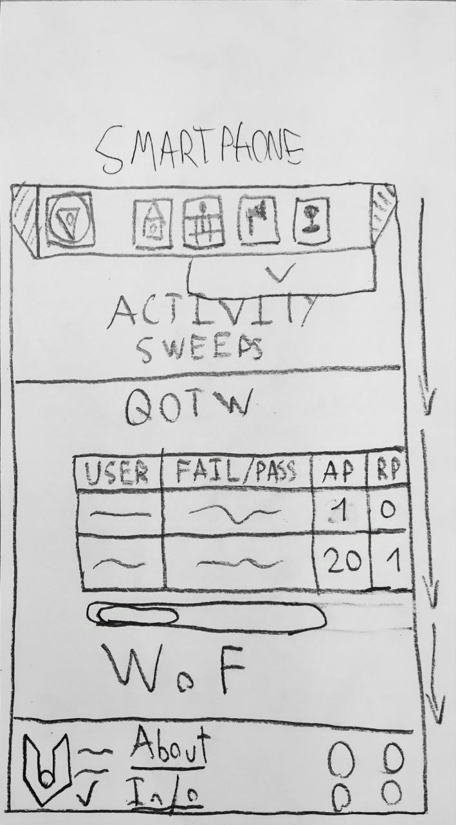

**6:**

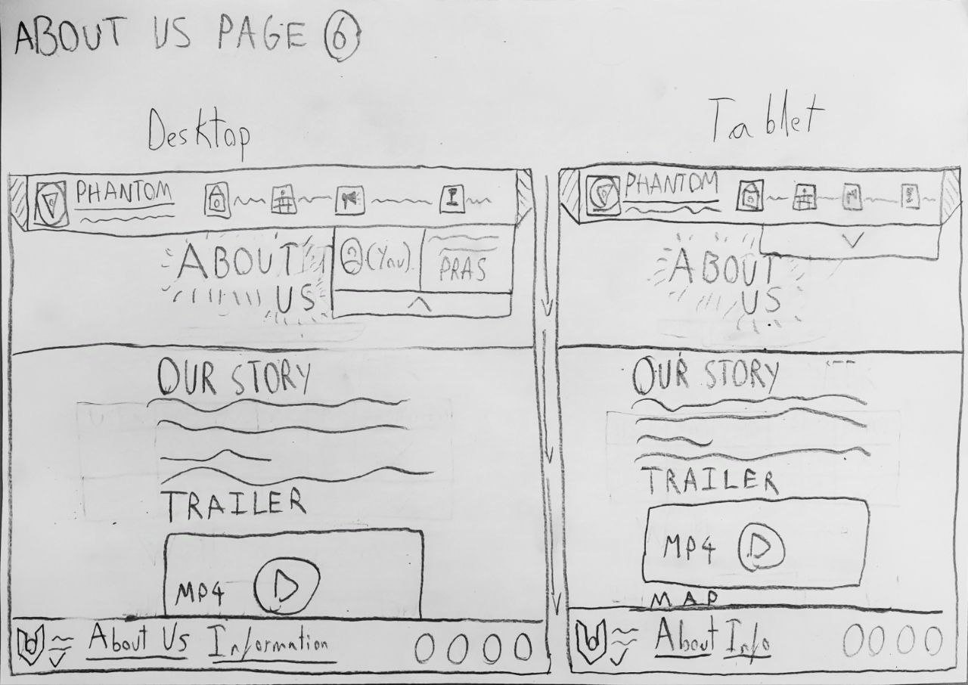

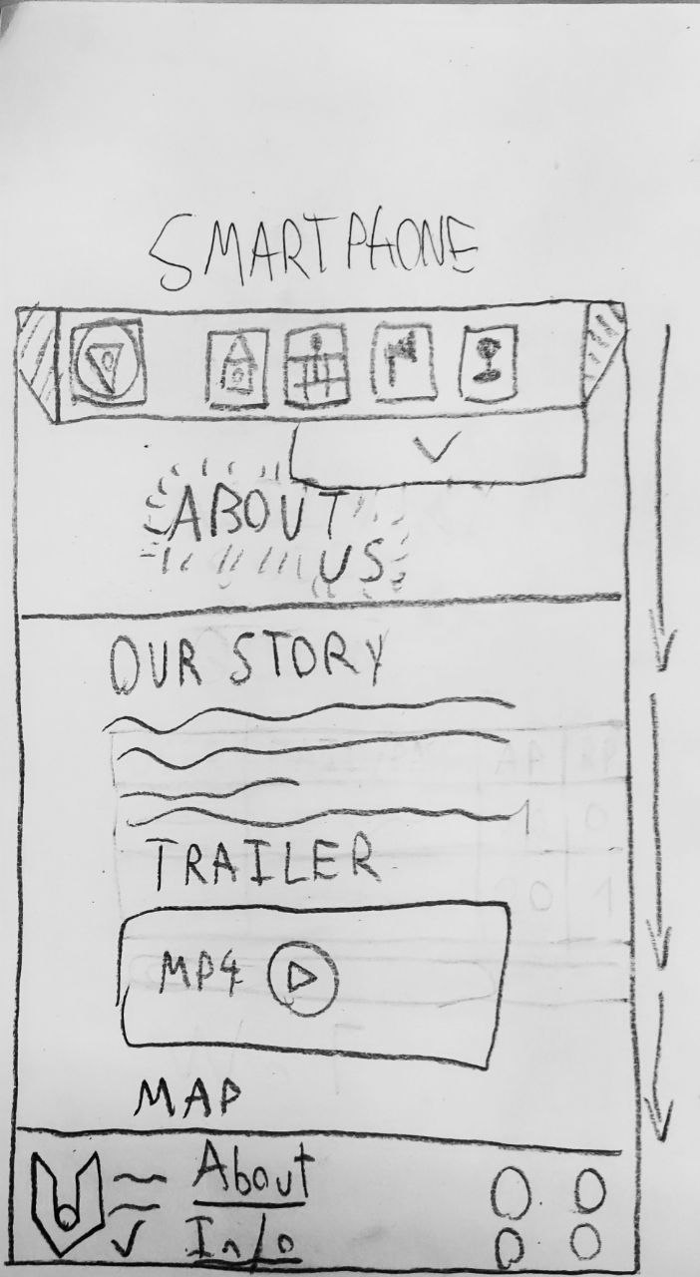

■▬▬▬▬▬▬▬▬▬▬▬▬▬▬▬▬▬▬▬▬▬▬■

■

## **[#3-2] – Wireframe**

**This section will explain each page of the website, including its purpose, design principles, descriptions of the most important areas, and how the user can interact with each one.**

**Before diving into every page, there is some general information to explain, as it provides an overview of shared design features and technical details:**

* **Each page has a scroll bar, allowing users to scroll from the start to the end of the page to view all extended information.**
* **Every page, except the landing page, features a hero image at the top, separated from the page content by a dividing line.**
* **For some buttons like the "Log In" or "Register" and the “Verify” buttons, the Figure-Ground design principle is applied. Clicking on these elements triggers a pop-up, where buttons continue their respective actions, while images and videos expand to full size. I address a picture here of how it should look for the Log In or Register and the Verify buttons.**

**Figure Grounds:**

* *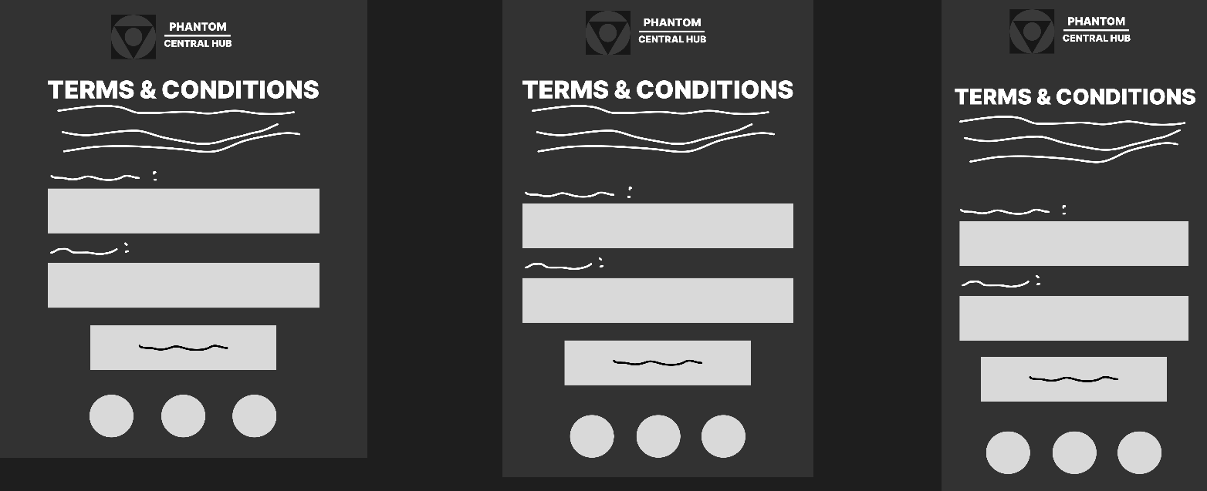****LOG IN or REGISTER*:**
* 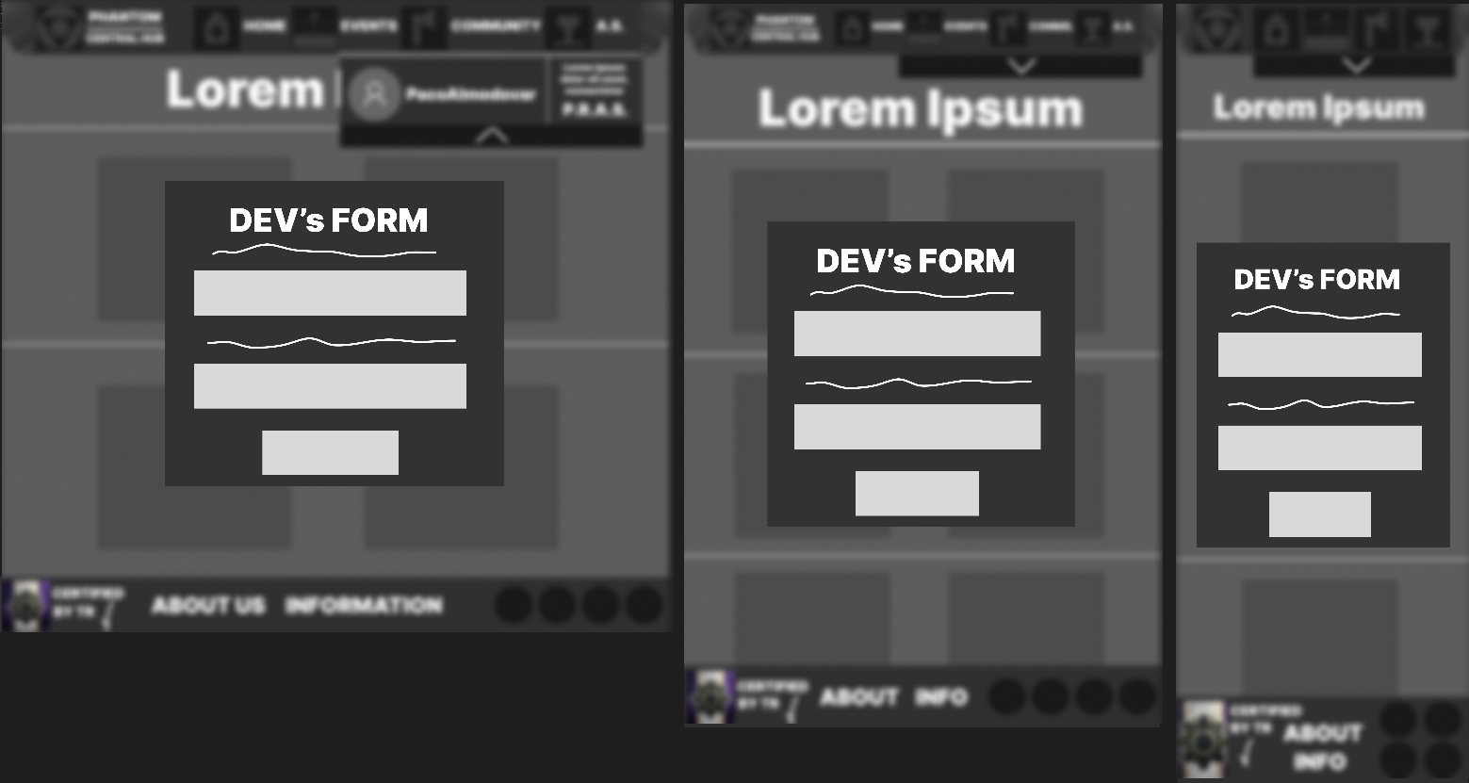***VERIFY BUTTON* (Community):**

**Also, images and videos can be selected to see them maximized. Images include a lens to zoom in and out the image. Videos (MP4s) include a fullscreen button on the bottom right of the video and a pause/start button along with a volume button on the bottom left of the video.**

**I address below how it should look:**

* 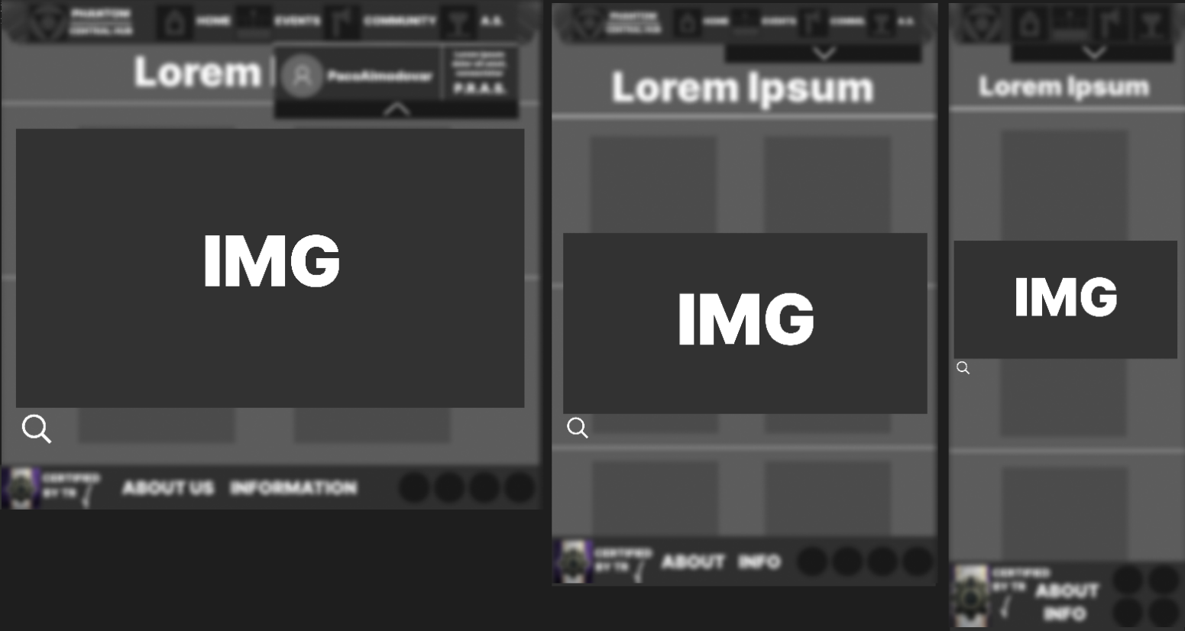***Images*:**
* 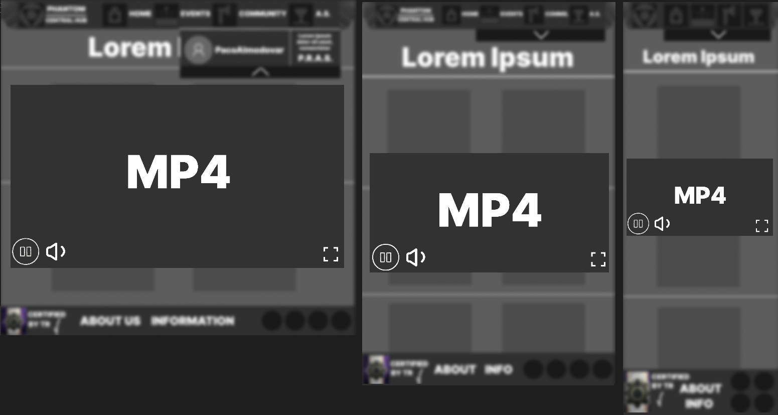***Videos*:**
* **Consistency is maintained across the website with a cohesive style, including uniform typography, buttons, and other recurring elements, aswell with respect of margins and good looking.**

**At this stage, everything is still tentative, as many elements are yet to be finalized. Typography, colors, and icons remain undecided—only a few, like the certification icon, are close to being set. Updates to backgrounds, additional symbols, and other design elements will be considered in future steps. This phase is simply a preliminary representation, giving an idea of how the page *might* look on the web, based on the previous sketch. Further refinements will be assessed in subsequent stages as the design evolves.**

**With this context, an explanation of each page follows below:**

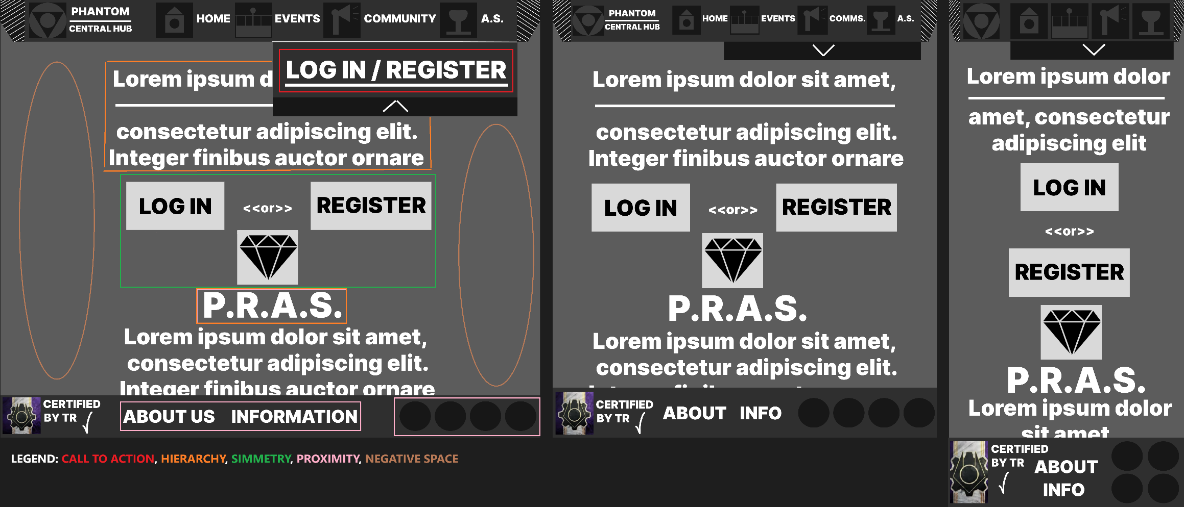**1:**

1. **LANDING PAGE:**

**Common regions implemented in all pages:**

* **HEADER:**

**A fixed header contains navigation links like Home, Events, Community, and A.S., along with a dropdown for the user, his settings and the “P.R.A.S” system. It’s accessible across all pages for consistency and ease of access.  
In this only page, the dropdown is used for a CALL TO ACTION for Log In and Register that it will be explained later this section.**

* **FOOTER:**

**The footer contains links to “About Us” and “Information,” along with social media icons and a certification badge, which establish credibility and provide transparency.**

**Area implemented in this single page:**

* **LOG IN/REGISTER SECTION (Main Content):**

**This is the primary focus of the landing page, with two large, inviting buttons to either register or log in. The P.R.A.S. icon below hints at benefits, building curiosity to encourage user interaction.**

**User Interaction inside this page:**

* **Log In or Register Buttons: Clicking either button opens a form for users to log in or register. This interaction is required to access more of the website, creating a secure environment where only registered users can proceed.**
* **Navigation Links: Users can explore “About Us” and “Information” sections to gain insight into the platform before registering, allowing them to familiarize themselves with the platform's mission and values.**

**Design Principles used in this page:**

* **CALL TO ACTION: The prominent Log In/Register links in the header dropdown are designed to capture users’ attention immediately, prompting them to act by clicking. This direct interaction encourages users to engage with the page as intended.**
* **HIERARCHY: These texts, as the one on the top of the body of the page or the P.R.A.S title are made to catch the user’s attention into big texts, directing users to the primary action needed on this page**
* **SIMMETRY: The balanced placement of elements creates a structured layout that feels stable and organized, giving users a comfortable starting experience.**
* **PROXIMITY: Related elements, such as the introductory text, Log In/Register buttons, and P.R.A.S. icon, are placed close together. This proximity reinforces their association and guides users through the registration process intuitively.**
* **NEGATIVE SPACE: Used to focus attention on core actions without visual clutter, giving a clean, straightforward experience that emphasizes the login process.**

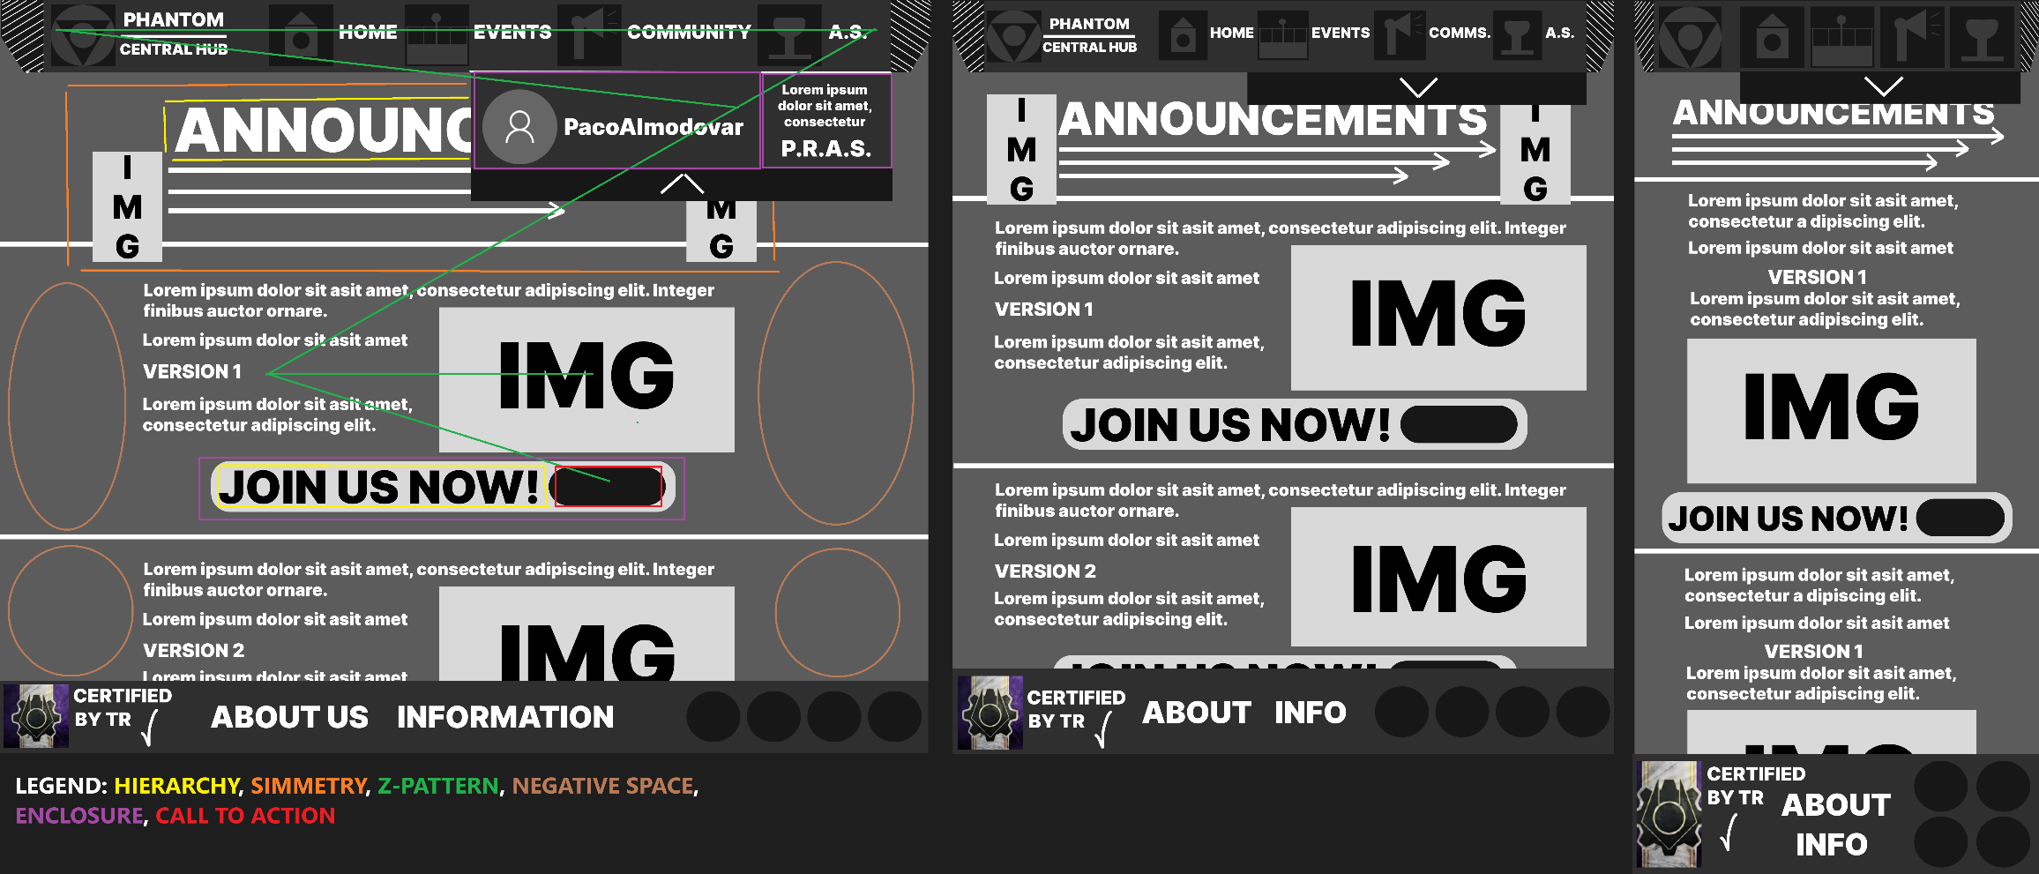**2:**

1. **HOME PAGE:**

**Once the user logs in and moves from the Landing Page to the Home Page, the header dropdown changes to display the username and icon, along with options and access to the “P.R.A.S.” system. This dropdown will remain consistent across all pages moving forward, and it is divided into two sections, which will be explained later. Now, let’s go over the Home Page details.**

**Section implemented in this page:**

* **ANNOUNCEMENTS SECTION (Main Content):**

**This section features different announcements, each with an image on the right and descriptive text on the left. Each announcement has a “Join Us Now” button, making it easy for users to engage with ongoing events.**

**User Interaction inside this page:**

* **Join Us Now (Call to Action): Clicking this button directs users to a relevant page, such as event details or a membership signup form, allowing users to participate in Phantom events or community activities.**
* **Navigation Links: The header links allow users to explore other parts of the site, encouraging users to engage with multiple aspects of the platform.**

**Design Principles used in this page:**

* **CALL TO ACTION: The “Join Us Now” button in the announcements section is prominently displayed to catch the user’s attention immediately, prompting them to take action. This button is intentionally designed to be highly noticeable to encourage interaction.**
* **HIERARCHY: The main “Announcements” title and the “Join Us Now” text are the focal point, making it immediately clear that this section is important and needs your services on this roleplay group. This guides user’s attention to the latest information and the way to join in Phantom.**
* **SIMMETRY: The layout is symmetrical, providing a sense of organization and predictability. Arrows under the title and aligned images enhance this balanced structure.**
* **Z-PATTERN: The content flows in a Z-pattern, which is a natural reading flow, leading users from the logo to the navigation, then to the announcements, and finally to the call-to-action button, maximizing engagement.**
* **NEGATIVE SPACE: Negative space is used around each announcement, keeping each section distinct and easy to read, preventing visual overload.**
* **ENCLOSURE: The “Join Us Now” text and button are enclosed within a designated area, making them feel distinct from the announcement content and highlighting them as a separate call to action.**

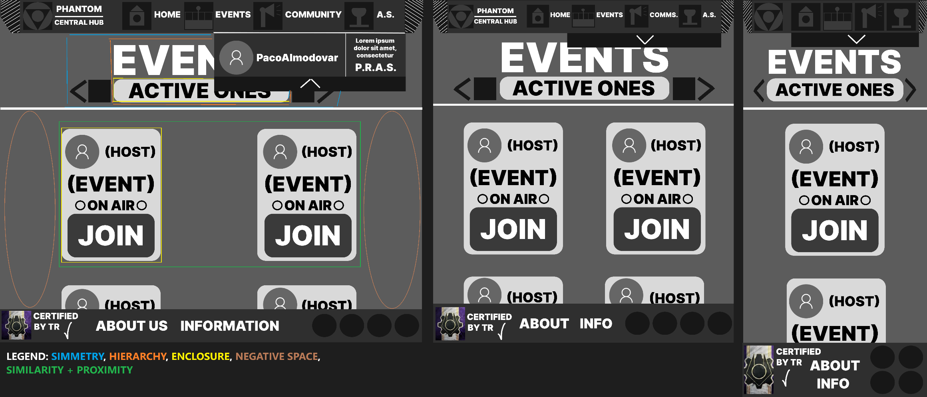**3:**

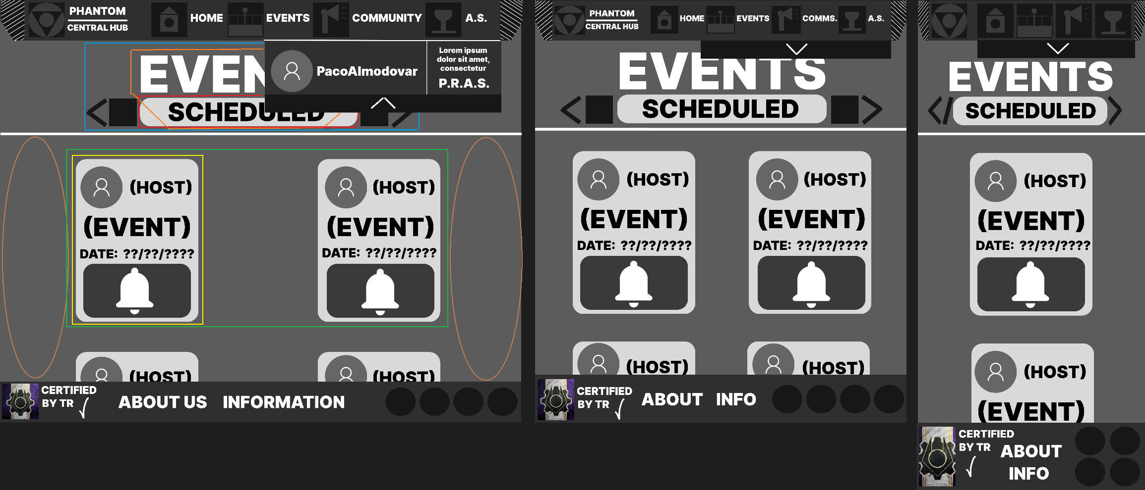

**NOTE: THE RED SQUARE MEANS ENCLOSURE TOO.**

1. **EVENTS PAGES:**

**Areas implemented in these 2 pages:**

* **EVENTS BLOCKS: Each block represents an individual event, showing the host, event title, and either the "ON AIR" label for live events or a scheduled date for upcoming ones. These blocks form the core of the page, allowing users to browse events.**
* **JOIN/NOTIFY BUTTON: The "JOIN" button for live events invites users to join instantly, while the bell icon for scheduled events allows users to receive a notification for future events.**
* **EVENTS TITLE HIERARCHY: Tabs at the top of the page distinguish between "Active Ones" and "Scheduled" events, allowing users to switch between currently live and upcoming events seamlessly.**

**User Interaction inside these 2 pages:**

* **Join Live Event: Clicking "JOIN" redirects the user directly to the event, fostering immediate engagement with the live content.**
* **Notification for Scheduled Events: Clicking the bell icon lets users request an email reminder for a scheduled event, providing a convenient way to stay informed without manually checking the schedule.**
* **Navigation Tabs: Users can navigate between active and scheduled events by selecting the respective tab, enabling them to find events based on their availability.**

**Design Principles used in these 2 pages:**

* **CALL TO ACTION: The “Join Us Now” button in the announcements section is prominently displayed to catch the user’s attention immediately, prompting them to act. This button is intentionally designed to be highly noticeable to encourage interaction.**
* **HIERARCHY: The main “Announcements” title and the “Join Us Now” text are the focal point, making it immediately clear that this section is important and needs your services on this roleplay group. This guides user’s attention to the latest information and the way to join in Phantom.**
* **SIMMETRY: The layout is symmetrical, providing a sense of organization and predictability. Arrows under the title and aligned images enhance this balanced structure.**
* **Z-PATTERN: The content flows in a Z-pattern, which is a natural reading flow, leading users from the logo to the navigation, then to the announcements, and finally to the call-to-action button, maximizing engagement.**
* **NEGATIVE SPACE: Negative space is used around each announcement, keeping each section distinct and easy to read, preventing visual overload.**
* **ENCLOSURE: The “Join Us Now” text and button are enclosed within a designated area, making them feel distinct from the announcement content and highlighting them as a separate call to action.**

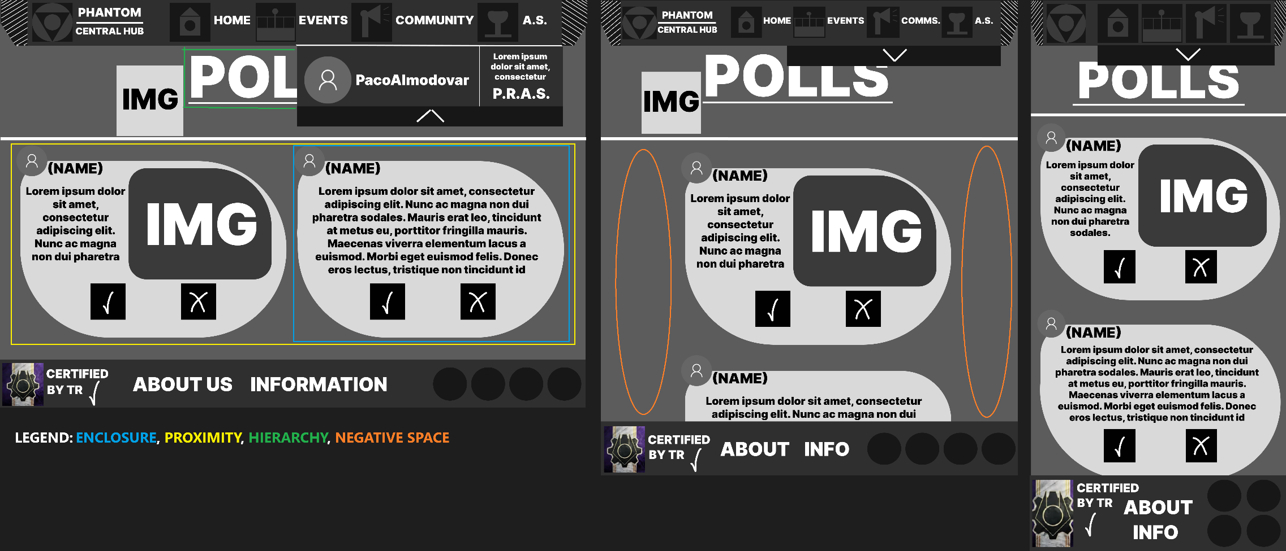**4.1:**

1. **POLLS PAGE:**

**Areas implemented in this page:**

* **POLL ENTRIES: Each poll entry consists of the question and the voting options, some of them include an image or video along with the brief explanation, which users can interact with directly.**
* **VOTING BUTTONS** **(✓ and ✕): These buttons allow users to choice if they are agreed or not with a poll. Once they vote, they might see the number of votes increase. Once the vote ends it will send an e-mail if the poll was successful or denied to every user who vote.**

**User Interaction inside this page: Users select their response by clicking on either voting button. This interaction likely provides real-time feedback, such as showing the number of voters, which engages users and encourages further participation.**

**Design Principles used in this page:**

* **Enclosure: Each poll is encased, with only the poll's profile picture extending slightly beyond the border.**
* **Proximity: The poll question, voting buttons, and profile icon are grouped closely together within each entry. This proximity visually connects these elements, helping users recognize each set of options as belonging to a single poll.**
* **Hierarchy: The title of the page is prioritazed visually. This clear hierarchy ensures that users know which page they are in and know what is about.**
* **Negative Space: Only on tablet there are negative spaces, for clarity and clear margin space, this is for not overwhelm the user.**

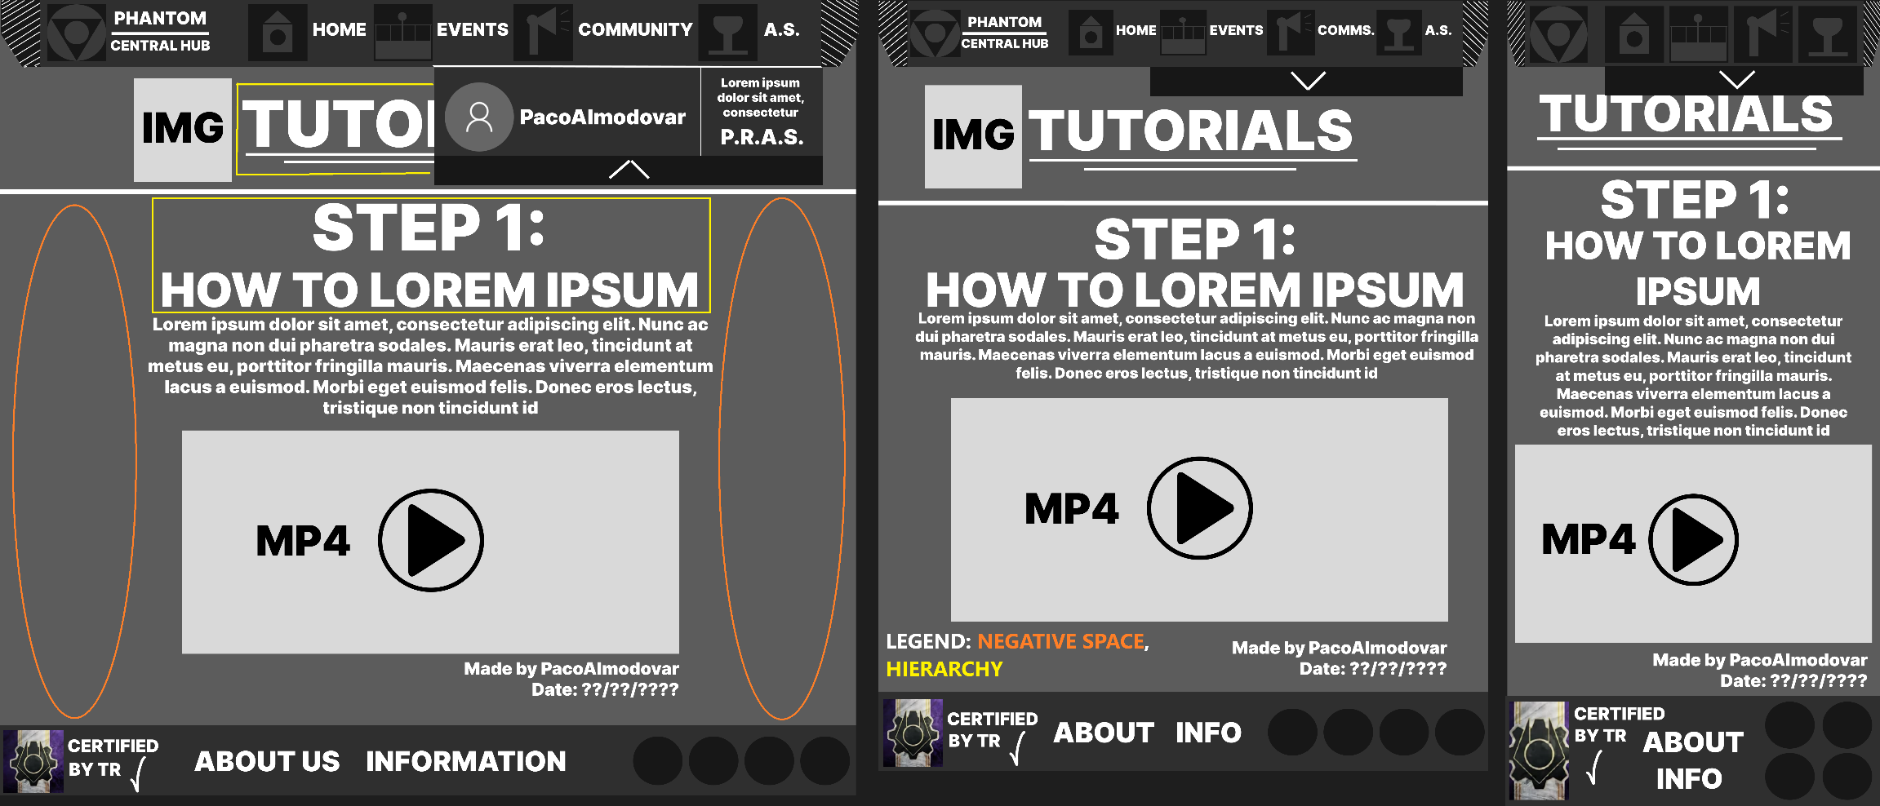**4.2:**

1. **TUTORIALS PAGE:**

**Areas implemented in this page:**

* **STEP LABEL and INSTRUCTIONAL TEXT: The step label provides clear guidance on the order, while the instructional text offers necessary details for completing each part.**
* **Media: The play button on the video invites users to interact by watching a demonstration, adding a visual aid that enhances the instructional content.**

**User Interaction inside this page: Users click on the play button to view the tutorial video for each step, enabling them to engage with the content actively. This interaction provides visual reinforcement for the instructions, making the tutorial easier to follow.**

**Desing Principles used in this page:**

* **Hierarchy: Each tutorial step is marked by a prominent label (e.g., "Step 1"), followed by instructional text and a video. This hierarchy ensures users understand the sequential nature of the tutorial and know where to begin within each step.**
* **Negative Space: There are negative spaces, for clarity and clear margin space, this is for not overwhelm the user.**

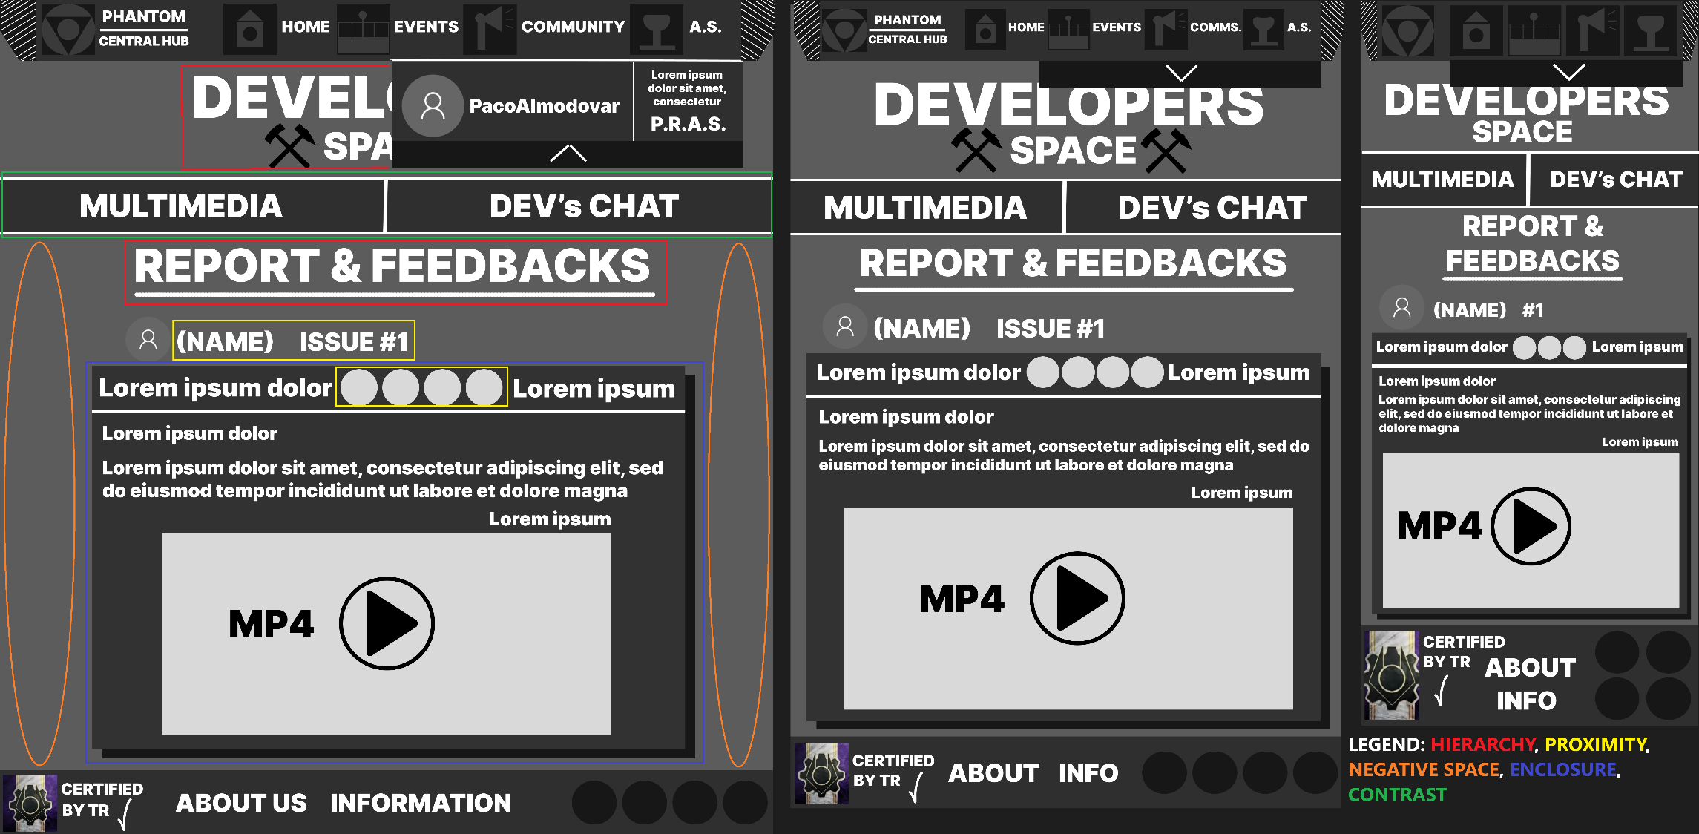**4.3:**

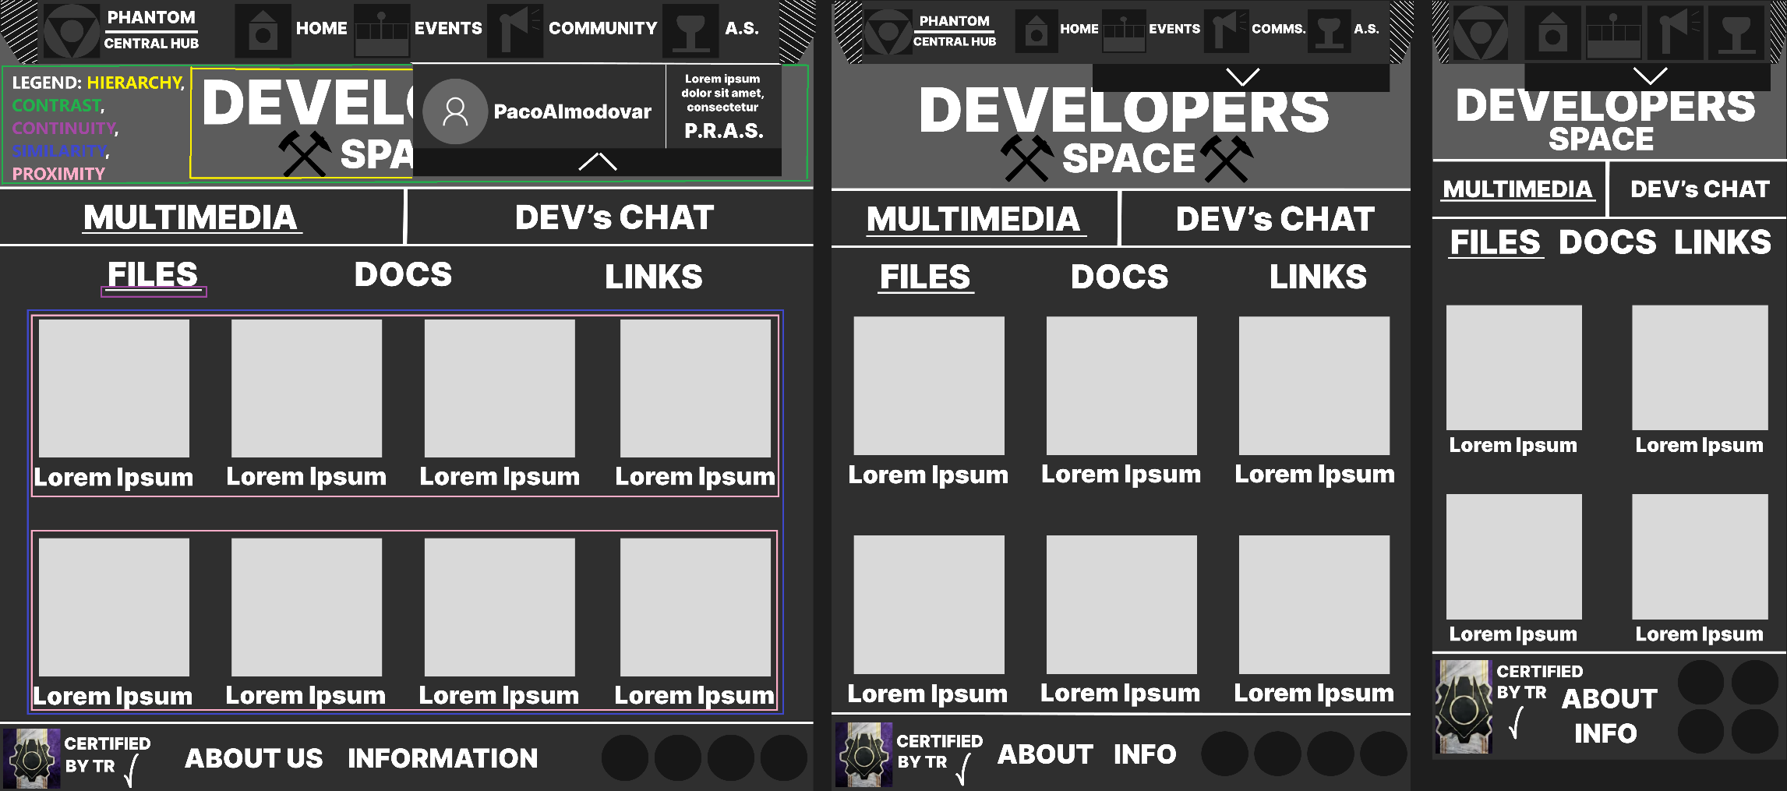

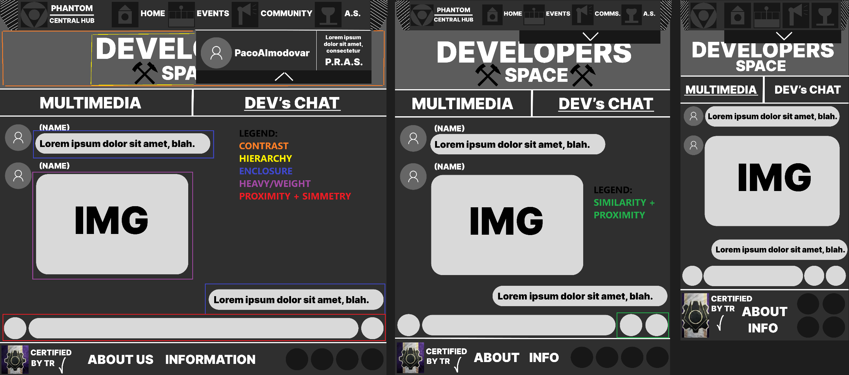



1. **DEVELOPERS PAGE:**

**On this page, there is a title with two images on either side, creating symmetry. There are three main sections: the main page and two dropdowns.**

* **Main Page – “REPORTS & FEEDBACKS”**
* **Areas implemented:**
* **"REPORT & FEEDBACKS" Section: The central area where users can view feedback reports. It includes the issue title, an issue description, and an MP4 media placeholder, indicating a video.**
* **Issue Details: Contains basic descriptions, issue tags, and videos.**
* **Developer’s interaction and consequences:**
* **Issue Navigation: Developers can click on different issue titles, leading to different issue details.**
* **Media Interaction and Engagement: The MP4 play button suggests the developer can click to view videos or other media related to each issue. Video or multimedia components can make feedback more engaging and comprehensible.**
* **Enhanced Understanding: Developers can explore different feedback and reports, allowing them to stay updated on the current issues and project needs.**
* **Design principles used:**
* **Hierarchy: Bold titles and headings, such as "REPORT & FEEDBACKS", the title of the page and the names along with the issues establish a clear reading order, directing the developer’s focus to the main sections.**
* **Contrast: The background, text, and icons use high contrast, improving readability and emphasizing key sections.**
* **Proximity: Related elements, like issue titles along with the name of the user and the emoticons, are grouped closely together, helping users quickly identify related content.**
* **Enclosure: The use of boxes around each issue creates a common region, visually grouping items together.**
* **Negative Space: There are negative spaces only in the desktop version of the website, but, it has a good use for clarity and clear margin space, this is for not overwhelm the developer user.**
* **First Dropdown: Multimedia**
* **Areas implemented:**
* **Sections of the Multimedia Dropdown: This area is divided into "FILES," "DOCS," and "LINKS" sections, where users can find resources. Each section has a uniform icon style with a description, each section has the same style.**
* **Developer’s interaction and consequences:**
* **Accessing Files and Documents and its resource accessibility: Developers can click on files, documents, or links to view or download resources. Quick access to necessary files or documentation supports developers by providing centralized project resources.**
* **Filtering by Section: The division into "FILES," "DOCS," and "LINKS" makes navigation easier, enabling users to find resources specific to their needs.**
* **Increased Efficiency: The grid layout and labeled sections allow users to locate and retrieve files easily, boosting efficiency in resource management.**
* **Design principles used:**
* **Hierarchy: Bold titles and headings, such as the title of the page and the multimedia sections establish a clear reading order, directing the developer’s focus to the main sections and what is about.**
* **Contrast: The background, text, and icons use high contrast, improving readability and emphasizing key sections, this is focused on the title of the page and its background.**
* **Continuity: The arrangement of images, icons and descriptions within each grid item leads the user’s eye smoothly across the grid layout.**
* **Similarity: Each image and its descriptions/links are similar, helping users to know that these are information related of the same type.**
* **Proximity: Related elements, like images and its descriptions/links, are grouped closely together, helping users quickly identify related content.**
* **Second Dropdown: Dev’s Chat**
* **Areas implemented:**
* **Developer’s Chat Area: A space where developers can read messages and interact with media, fostering collaboration.**
* **Chat Bubbles and Media Attachments: Each chat message bubble is accompanied by a user icon, text, and media.**
* **Developer’s interaction and consequences:**
* **Sending Messages: Users can type and send text or image-based messages to other developers.**
* **Image Viewing: Clicking on image attachments may enlarge them or open them in a separate viewer for detailed inspection.**
* **Real-time Collaboration and Enhanced Teamwork: Developers can communicate in real-time, share images or documents, and discuss project issues directly. Interactive chat functionality allows developers to actively engage with each other, strengthening collaboration and faster issue resolution.**
* **Design principles used:**
* **Hierarchy: Bold titles and headings, such as the title of the page establish a clear reading order, directing the developer’s focus to the main sections and what is about.**
* **Contrast: The background, text, and icons use high contrast, improving readability and emphasizing key sections, this is focused on the title of the page and its background.**
* **Enclosure: Each message is encased on a chat bubble, with only the profile picture and name extending outside the bubble.**
* **Similarity + Proximity: This is applied on tablet and smartphone where there are 2 circle boxes on the right corner of the developer chat area. This helps users to know that these are related function button for the chat.**
* **Simmetry: The input label and its two buttons on each side makes a way of symmetry on the bottom of the chat area. This is only applied on desktop.**

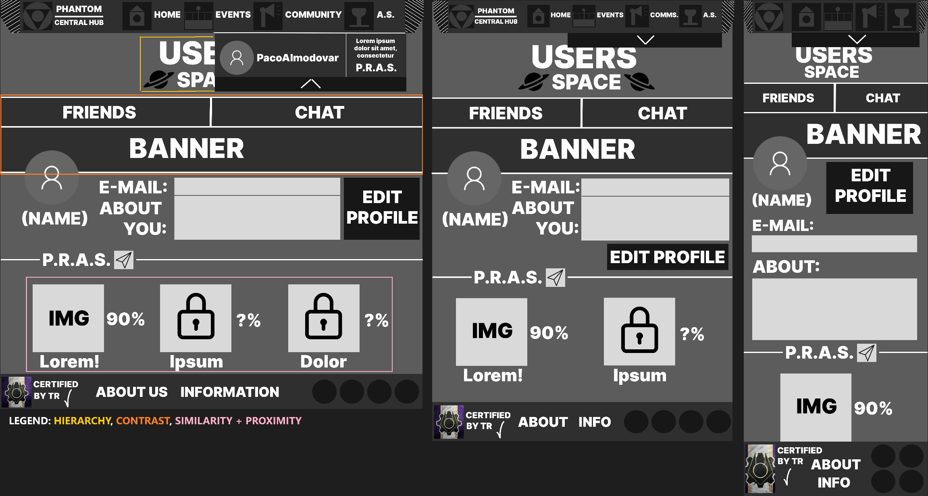**4.4:**

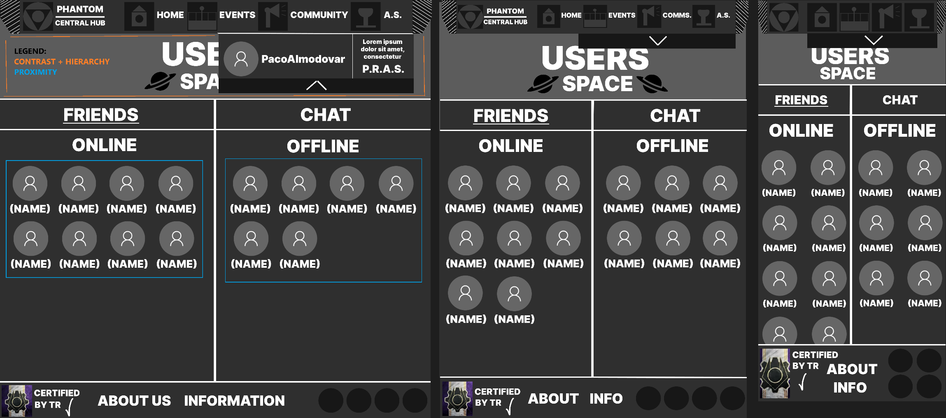

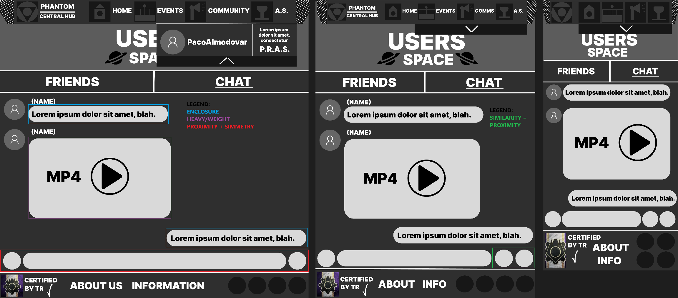

**CONTRAST**

**HIERARCHY**



1. **USERS PAGE:**

**On this page, there is a title with two images on either side, creating symmetry. The page is divided into three main sections: the main page and two dropdowns.**

* **Main Page – Users Space**
* **Areas implemented:**
* **Profile Section: Contains the user's name, email, and about fields. The profile image area is circular, distinguishing it from the other rectangular content areas like the banner.**
* **Personalized Recognition and Achievement System (P.R.A.S.): The icons/images and labels like locked icons provide visual achievements for users and how to get them, listed on the page status.**
* **Edit Profile: A button that allows users to make changes to their profile.**
* **User’s interaction and consequences:**

**Users can edit their profile by clicking the "Edit Profile" button, which likely takes them to an edit the information labelled on their name, about, email, banner, profile picture and maybe more. Hovering over icons might display additional information. Locked icons suggest restricted achievements, which may prompt users to get them for any way possible (for example., unlock through progress or actions inside the roleplay group).**

* **Design principles used:**
* **Hierarchy: The title of the page and the user’s profile section is prominently placed, the user’s profile section emphasizes the user's identity with large text for "BANNER" and personal information.**
* **Contrast: Black-and-white color contrast enhances readability, especially for the "BANNER" of the user and the 2 dropdowns.**
* **Similarity + Proximity: Related elements, like the user’s achievements and its description are grouped closely to indicate they belong together.**
* **First Dropdown: Friends**
* **Areas implemented:**
* **Friends List: Divided into "ONLINE" and "OFFLINE," each section contains friend’s profile images and names.**
* **User’s interaction and consequences:**

**Clicking on a friend’s icon might allow users to initiate a chat or view more details about the friend. The categorization into online and offline provides users with instant context about their friend’s availability.**

* **Design principles used:**
* **Hierarchy: The title of the page and the “ONLINE” and “OFFLINE” lists are prominently placed, this focused the user’s view readability on the main sections.**
* **Contrast: The background, text, and icons use high contrast, improving readability and emphasizing key sections, this is focused on the title of the page and its background.**
* **Proximity: For each friend, the profile picture and name are displayed with a proximity design, grouping these elements closely.**
* **Second Dropdown: Chat**
* **Areas implemented:**
* **Chat Area: Displays text and multimedia messages in a linear format from various users.**
* **Input Field: Located at the bottom, where users can type and send messages and media.**
* **User’s interaction and consequences:**

**Users can click on the "CHAT" tab to view or engage in conversations. Typing in the input field and pressing the send button will post a message the user is writing, visible in real-time for many users. The input field also has a button along with it for multimedia interaction, letting users share media directly in the chat and they can click on media sent by other users.**

* **Design principles used:**
* **Hierarchy: The title of the page is prominently placed, this focused the user’s view readability on what page they are located.**
* **Contrast: The background, text, and icons use high contrast, improving readability and emphasizing key sections, this is focused on the title of the page and its background.**
* **Simmetry: The input label and its two buttons on each side makes a way of symmetry on the bottom of the chat area. This is only applied on desktop.**
* **Enclosure: Each message is encased on a chat bubble, with only the profile picture and name extending outside the bubble.**
* **Similarity + Proximity: This is applied on tablet and smartphone where there are 2 circle boxes on the right corner of the developer chat area. This helps users to know that these are related function button for the chat.**

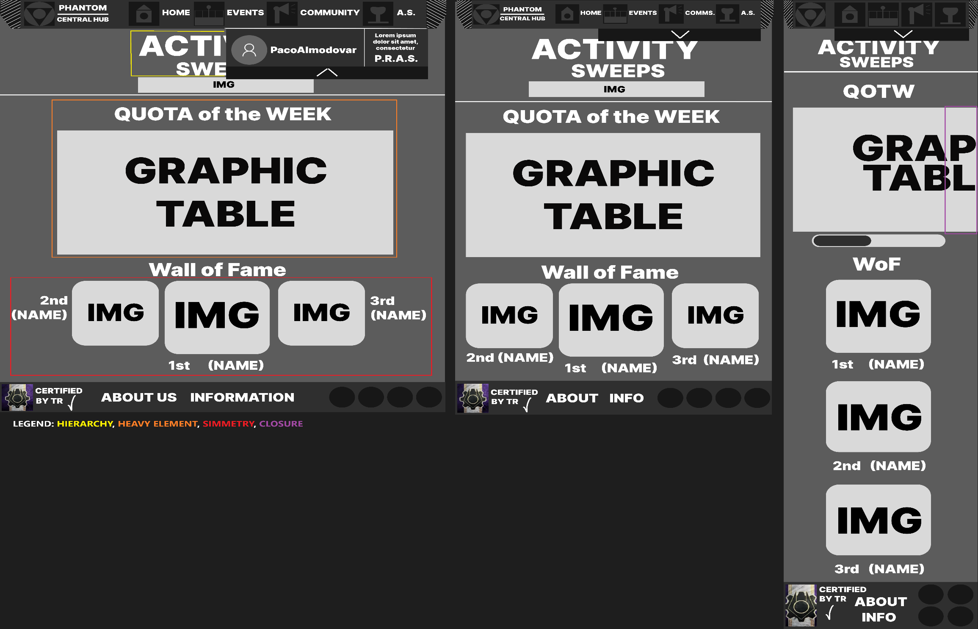**5:**

1. **ACTIVITY SWEEPS PAGE:**

**Areas implemented in this page:**

* **Quota of the Week: This section displays a weekly goal that users are encouraged to achieve, providing motivation and focus for the week’s activities.**
* **Wall of Fame: Showcases the top achievers, potentially with profile images and names, creating a visible reward for active users and encouraging others to participate.**

**User Interaction inside this page: Users interact indirectly by working towards the weekly goal or by participating in activities to earn a spot on the Wall of Fame. The visual emphasis on top achievers fosters a sense of friendly competition, motivating users to increase their engagement with the platform. There’s no button or anything else for the user to act consequently, this page only shows information to the user and for his good inside the community.**

**Desing Principles used in this page:**

* **Hierarchy: The title of the page and each section of it are positioned as a priority, these hierarchies are ordered from title to the last section.**
* **Simmetry: The Wall of Fame section likely uses a symmetrical layout for the top achievers, creating a sense of order and balance. This symmetry gives the Wall of Fame a prestigious appearance, enhancing its importance.**
* **Heavy Element: The graphic table of the QOTW applies this principle. This large, centered graphic box acts as a significant visual anchor. It's a bold, sizable graphic element that provides balance at the top of the page, setting the page's structure and drawing the user’s attention immediately. The large size and space (that will be filled in the future steps) around it make it feel substantial.**

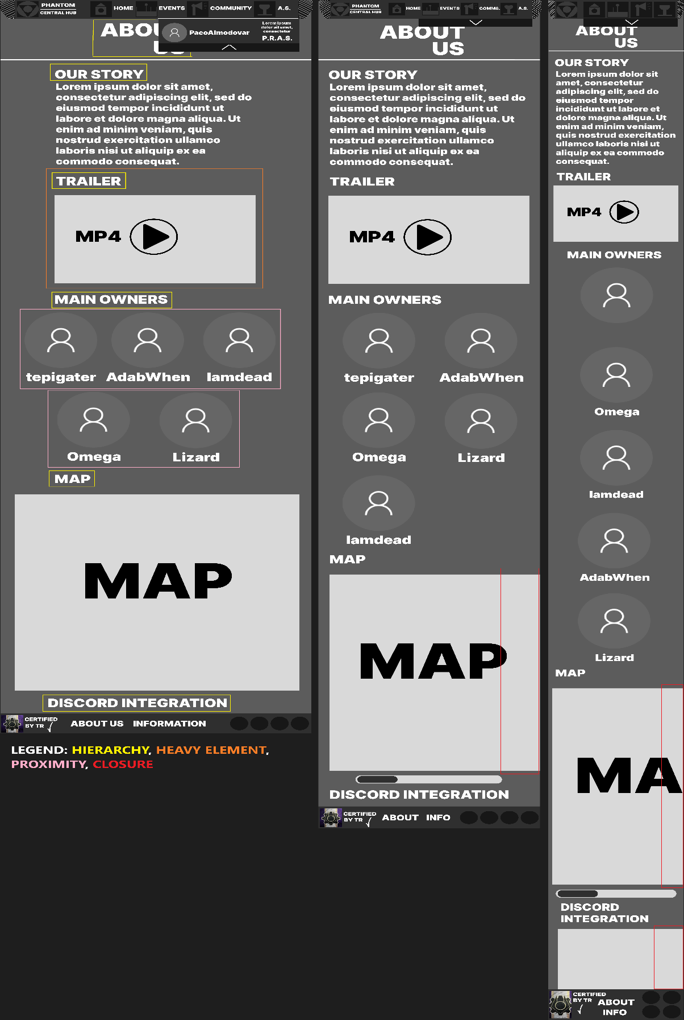**6:**

1. **ABOUT US:**

**Areas implemented in this page:**

* **OUR STORY: This area provides a textual description of the roleplay group, its purpose and story. This introduction establishes the context for new users.**
* **TRAILER: A prominent visual element that likely features an embedded video. This section acts as a dynamic, engaging introduction to the community.**
* **MAIN OWNERS: This section shows key members or owners represented by icons and usernames, giving users a sense of the community leadership. It serves to humanize the organization, showing the faces behind it.**
* **MAP: Likely provides a visual representation, either of a virtual map for in-game use. This helps users understand the geographical layout of the game.**
* **DISCORD INTEGRATION: This section allows users to know how the community's Discord server works, enhancing interactivity by enabling communication and engagement through a guide about the server in said platform.**

**User Interaction inside this page:**

* **Watch the Trailer: Clicking the play button in the "TRAILER" section triggers video playback, allowing users to learn more about the roleplay group, potentially increasing engagement.**
* **Exploring Main Owners: Users may be able to click on the icons in the "MAIN OWNERS" section, possibly leading to profiles or contact options for each owner. This feature would foster a sense of familiarity and accessibility with the community leaders.**
* **Map Interaction: If the "MAP" section is interactive, users could click to explore various locations and the information about it, providing them with a better understanding of the environment. This feature is particularly useful in roleplay game communities where familiarize with the in-game locations is relevant.**
* **Discord Integration: Users can click the "DISCORD INTEGRATION" area to join or connect with the Discord community. This interaction opens a bridge between the web page and the platform, enabling users to know the structure of the community Discord server and what they do.**

**Desing Principles used in this page:**

* **Hierarchy: Various titles for sections and the page one are positioned as a priority, these hierarchies are ordered from title of the page to the last title of sections.**
* **Heavy Element: The trailer, map and discord integration apply this principle. These large boxes act as a significant visual anchor. They are bolding, sizable graphic elements that provide balance extending to the end of the page, setting the page's structure and drawing the user’s attention immediately. Each box will be filled on future steps as said on Activity Sweeps explanation.**
* **Proximity: The “OWNERS”, mainly seen on desktop and tablet format, take a proximity from each other making them related.**
* **Closure: Only applied on tablet and smartphone, this principle does to the map and discord integration a sign of more information if you scroll it, this is how this principle is taking action, so the user can see more about the map or the discord integration by scrolling it to the right or left.**

■▬▬▬▬▬▬▬▬▬▬▬▬▬▬▬▬▬▬▬▬▬▬■

■

## **[#3-3] – Colour Palette**

**In this step, the color palette should aim to convey professionalism, prestige, and a sense of belonging to a spy roleplay community like Phantom. The colors must be immersive to engage the user and draw them into the roleplay experience of spying on rebels, as Phantom does. They should also appear serious, ensuring that users perceive the page as a genuine spy-themed platform. Additionally, the colors should align with the official logo, which embodies all these characteristics.**

**Here is the logo providing the colour scheme:**

**The colours should also ensure readability and usability, so adjustments may be necessary to enhance the user experience without making the page darker or harder to navigate than the logo itself. This section will explain why the selected palette is the best fit for the website, considering the logo's colours.**

**Now will explain why the selected palette, derived from the logo's colours, is the best fit for the website: CHOSEN PALETTE**

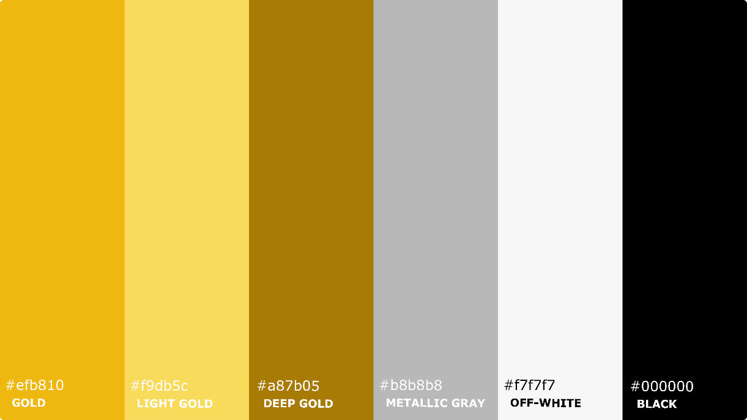

**This proposed colour palette it matches perfectly with the logo and sense of this roleplay group website. The gold tones makes the user feel prestige and sophistication making it serious in its deepest and elegant in its clarity, these gradient golds are grounded by the neutral greys and whites, the metallic gray colour conveys balance complementing the gold tones, the off-white colour remains bright for simplicity and clarity, while black provides the seriousness and authority needed for a serious roleplay site.**

**When combined, the palette conveys a balance of professionalism, prestige, and immersion that aligns seamlessly with the spy roleplay theme.**

**PRINCIPAL COLOUR**

** Deep Gold (#A87B05).**

**This dark colour represents prestige, depth and seriousness, these are important themes for the PHANTOM community. It’s a colour that makes a good contrast with the black colour and brighter golds complementing the colour scheme, helps to make the footer and header more refined.**

**It can be used for lower headings or secondary titles, because it provides** **visual distinction without removing relevance the main headings or titles, also for division lines of many sections, for the header and footer to create a separation from the main content, and button outlines making them good looking like the icon’s outlines**

**CONTRAST COLOUR**

** Black (#000000).**

**This colour symbolizes power, secrecy, and authority, making it perfect for creating sharp contrasts with lighter colours like gold as it is explained before and white used for the background. It ensures readability and emphasizes.**

**It can be used for the main text colour for the page because ensures high contrast and readability against the white background, also for outlines of geometric shapes, logos, icons or any other to enhance visual structure in some elements.**

**SECONDARY COLOURS**

** Light Gold (#F9DB5C).**

**This colour complements the primary gold and adds warmth and elegance, this creates a visual colour hierarchy or gradient while ensuring less prominent areas that are still visually appealing.**

**It can be used for hover effects on buttons and links, for decorative patterns and subtle ideas or areas, and of course can be applied on actions for visual interest like animations on icons, obviously without overpowering the design but making it more interactive.**

** Gold (#EFB810).**

**Can be used for secondary colour too, because its tone that still adds prestige, importance and exclusivity. This colours immediately draws the user's attention and emphasizes the professionalism and sophistication of the platform.**

**It can be used for buttons as call to actions or more, also with important words with a bold style and titles made by headings, also for the shadows of some geometric shapes, logos, icons, etc.**

**NEUTRAL COLOURS**

** Metallic Gray (#B8B8B8).**

**This colour is used because of it is versatile, balances the boldness of gold and black, creating a feel more polished.**

**It can be used also for some divisions like the deep gold does to separates sections without distracting from the content and shadows of shapes like the gold colour does, also for caption texts or less informative texts or not so important.**

** Off-White (#F7F7F7).**

**This colour is used to provide a clean and simple background that ensures all elements are easy to read while maintaining a bright layout that apply readability.**

**It can be used for the background of the page because the content and colours are clearly visible there’s no problem with it, and for texts in black backgrounds as a way of contrast too only made for the black colour.**

**VISUAL SAMPLES**

**To know much more of how the chosen colour palette would look in the roleplay group website, an example is going to be addressed below of the Home Page with said colour palette applied to it on Desktop format.**

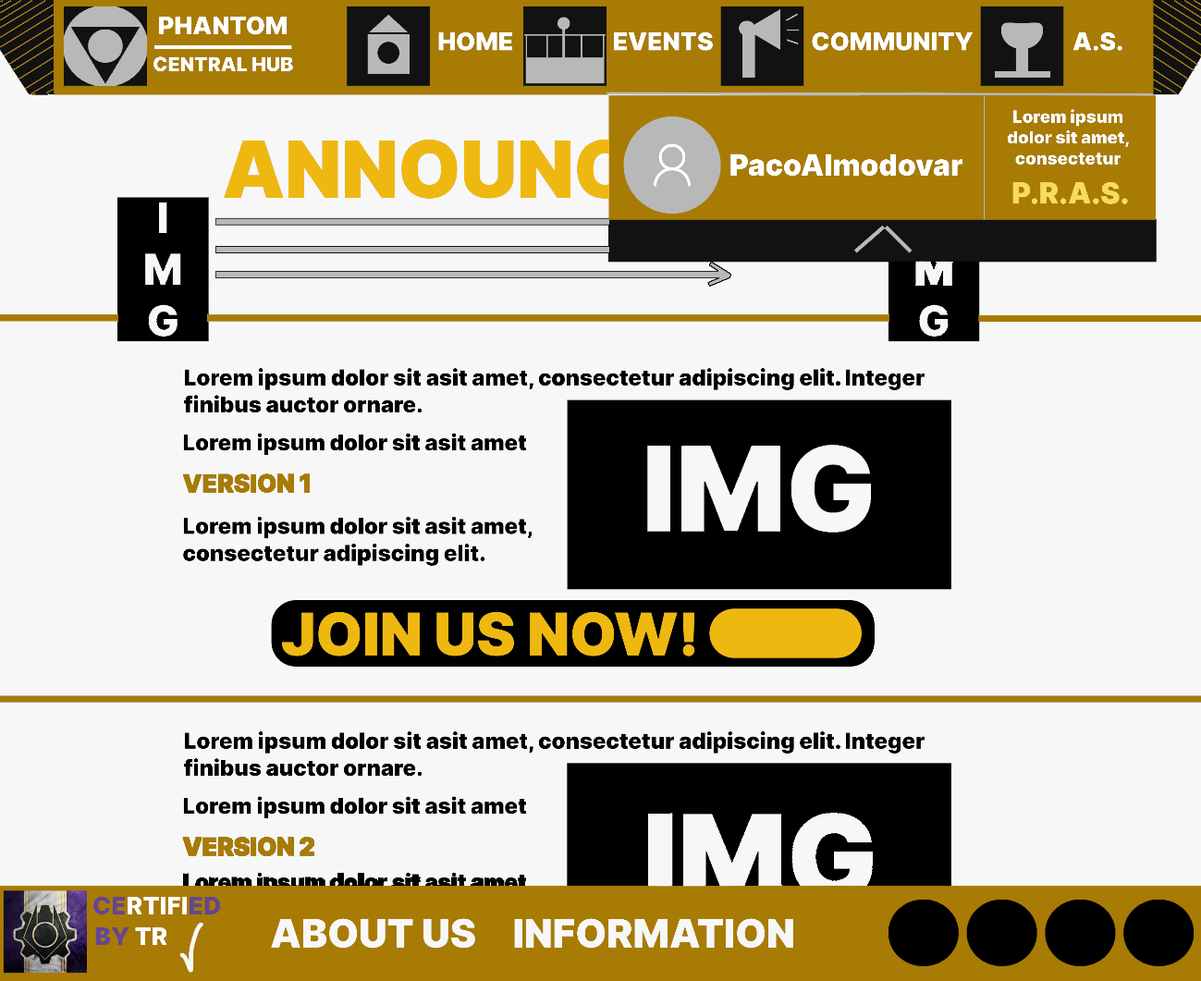

**BACKUP PALETTE**

**The backup palette ensures continuity with the original design while providing a vibrant alternative for temporary or event-specific sections. The purple tones (#6a0dad, #ae6fde, #431578) reflect mystery and creativity, enhancing the immersive experience of the PHANTOM brand, these shades can be used in temporary event-specific sections, as seen before on the footer to decorate the gradient colours of the logo of the Robine game, or seasonal themes to refresh the visual experience without losing the serious and immersive tone of the website. The neutral greys (#adadad, #545454) anchor the palette by maintaining balance and ensuring readability.**

**These colours provide stability and clarity, echoing the professional tone of the primary palette. This second option ensures that the backup palette aligns with the original while offering flexibility for dynamic content.**

**In this backup palette, the Primary Colour is Royal Purple (#6a0dad) because symbolize mystery for the spy-themed, the Contrast Colour is Dark Violet (#431578) because is the deepest gradient colour, the Secondary Colour is Lavender (#ae6fde) because is the lighter shade that adds elegance to the emphasis, and the Neutral Colours are Light Gray (#adadad) and Dark Gray (#545454).**

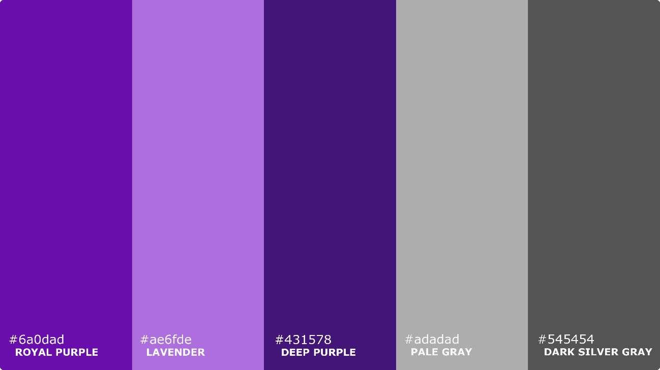

**DISCARDED PALETTES**

1. **Military Sea Blue Palette**

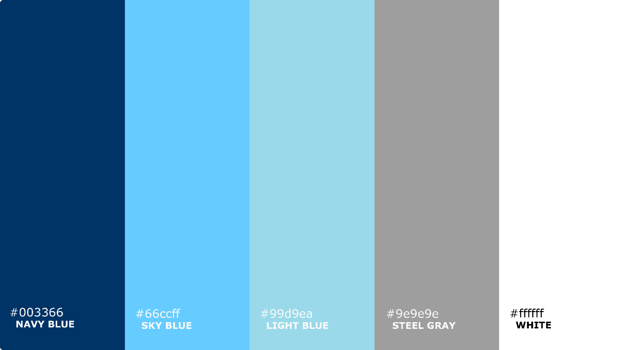

**The Military Sea Blue Palette was discarded because, although its shades of blue (#003366, #66ccff, #99d9ea) convey a sense of calm and professionalism, they do not align with the immersive and mysterious spy theme of the PHANTOM brand. The lighter blue tones feel too modern and tech-oriented, which detracts from the sense of seriousness and prestige needed for the website. Additionally, the lack of warmth in the palette makes it less engaging, reducing its effectiveness in creating an inviting atmosphere for users.**

**Anyway, if this palette worked, the Military Sea Blue Palette would place Dark Navy Blue (#003366) as the background for the header and footer, providing a solid foundation. Sky Blue (#66ccff) would be used for buttons and hover effects to make interactive elements stand out. Light Blue (#99d9ea) would work well for icons and small highlights to add a modern touch. Steel Neutral Gray (#9e9e9e) would be applied to borders and secondary text to ensure a balanced design, while White (#ffffff) would act as the main background colour for clarity and readability across the page.**

1. **Camo Forest Green Palette**

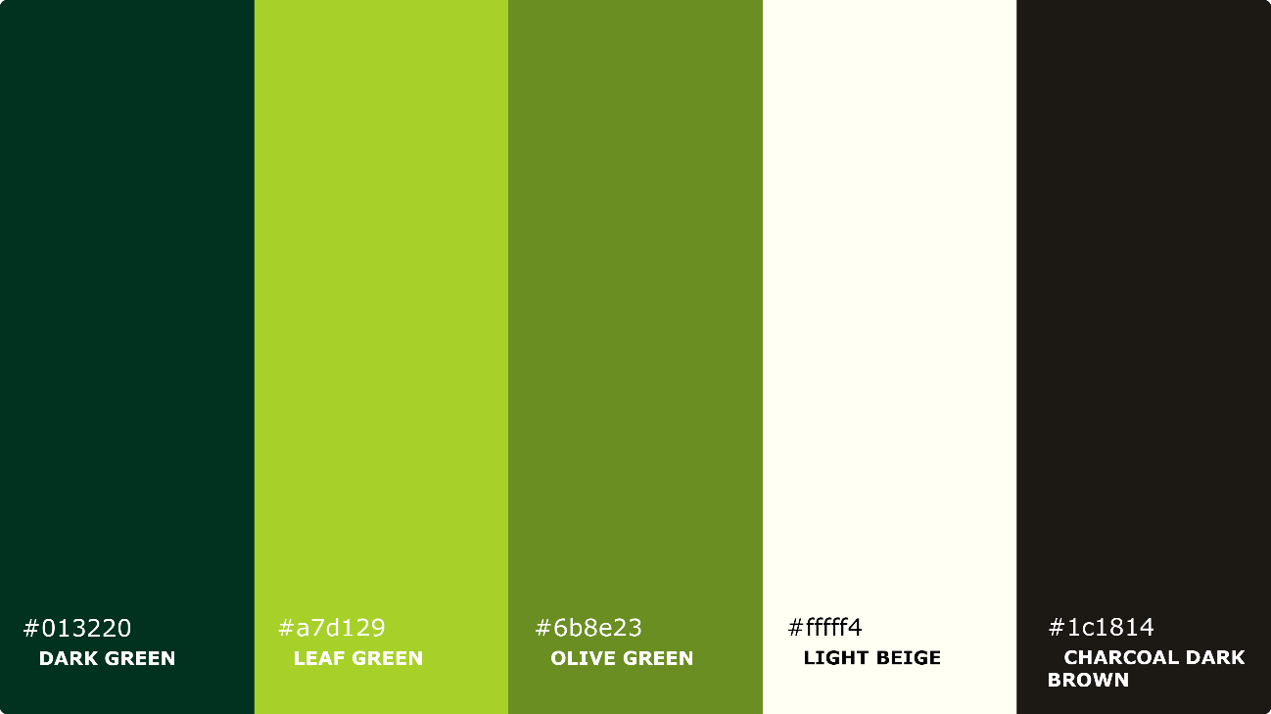

**The Camo Forest Green Palette was not selected because its earthy tones (#013220, #a7d129, #6b8e23) evoke nature, despite it makes a sense of camouflage, it still conflicts with the sophisticated and high-tech identity of the PHANTOM roleplay group.**

**While it might suit a survival-themed project, the green hues lack the sense of authority and exclusivity needed for a spy-focused design. Furthermore, the palette's overall balance does not provide the professional and polished look required for this project.**

**Although it was a good option, the Camo Forest Green Palette would use Dark Green (#013220) for the header and footer backgrounds, adding a bold and strong visual base. Leaf Green (#a7d129) would enhance buttons and hover effects, making them visually engaging. Olive Green (#6b8e23) would add subtle accents to dividers and icons for consistency. Light Beige (#fffff4) would serve as the main background colour to maintain a clean and bright layout, with Charcoal Brown (#1c1814) reserved for text and icons to ensure strong contrast and emphasis.**

■▬▬▬▬▬▬▬▬▬▬▬▬▬▬▬▬▬▬▬▬▬▬■

■

## **[#3-4] – Typography**

**For the *PHANTOM Central Hub* website, the typography is really important decision to make everything look professional and easy to read while matching the theme of the group. The idea is to use fonts that fit the military and stealth vibe but also make the website clear and organized. Titles should be bold and kind of futuristic style to grab attention, and the body text will be elegant and simple so users can read everything easily.**

**Talking about this with the client, they recommend me checking their documents for extract the typography they already use, this exact document you are reading is written on said typographies. I will embed some of their documents so you can see how they look with this typography:**

* [**PHANTOM Codex 5.0**](https://docs.google.com/document/d/1NgJfQ0hf8yU_roTLZmAxqYtQPy_CvCqVIGaHLYhlsJ0/edit?tab=t.0) **(Click on it).**
* [**Phantom Entrance Program [PEP] Guidelines**](https://docs.google.com/document/d/1QBvqZBY8pQqM3yX8FmWlDHu614taq9U19IPCEOBPN1Q/edit?tab=t.0) **(Click on it).**
* [**Phantom Tactician Entrance Program [PTEP] Guide**](https://docs.google.com/document/d/1vhzvC7agAniAeowfosSXlhbdTC5o17jK2vgrPc2xHjM/edit?tab=t.0) **(Click on it).**

**(Each one was written and edited by OmegaTraitor10 who helped with this idea, and AdabWhen, leader of Phantom, who gave to me the fonts that are needed for this project).**

**With these choices, the typography isn’t just about looking good, it’s also about making the site easy to use and giving it a serious and professional feel that matches what PHANTOM is all about.**

**Talking about the project characteristics influencing the typography choice are:**

* **Formality more than informality: The website needs a formal tone to align with PHANTOM's serious theme and its professional image.**
* **Longevity: Since this is a long-term project, the typography needs to stay relevant and not go out of style.**
* **Text quantity: There’s a mix of short, impactful titles on many sections and an amount of text inside boxes or across the page that should be easy to read for everyone. The chosen fonts ensure clarity for both.**

**The chosen typographies are:**

* **Aldrich (Titles): To attract readers with a futuristic style and clean. It should be used for titles, section headers, and attention-grabbing elements.**
* **Spectral (Text): It gives an elegant style, and simple text so is easy to read. It should be used for paragraphs, guides, and explanations.**

**Why these typographies combine each other?**

**There is no explanation about that, since the users from the client community named Draco and Aqua, which were the ones who decide this typography, left, there’s no exact explanation about why these 2 combines.**

**But at the view of some users from PHANTOM, apart from looking good, they said it looks dynamic, is a mix of fonts between the way of what the game is directed, on a futuristic military style, but on the other side you can read simple text with a modern, formal and professional style, giving the page the seriousness that it needs to fit with client standards.**

**DISCARDED TYPOGRAPHIES**

**These typographies were discarded because were deprecated for the website or they didn’t look good or overwhelm the page a lot**

**DISCARDED MAIN TYPOGRAPHIES USED FOR TITLES:**

**Orbitron: It felt too futuristic and added a kind of robotic style and didn’t blend well with the overall professional tone.**

**Exo 2: Though modern, its complexity reduced readability for titles and is simpler than it should be.**

**DISCARDED SECONDARY TYPOGRAPHIES USED FOR THE TEXT:**

**Montserrat: Although it is used on the PHANTOM Codex 5.0 document for some descriptions or credits because of its clean style, it felt too casual and didn’t match the elegant style needed for the body text.**

**Merriweather: Old style and didn’t fit the futuristic vibe of the website.**

■▬▬▬▬▬▬▬▬▬▬▬▬▬▬▬▬▬▬▬▬▬▬■

■

## **[#3-5] – Menu and navigation map**

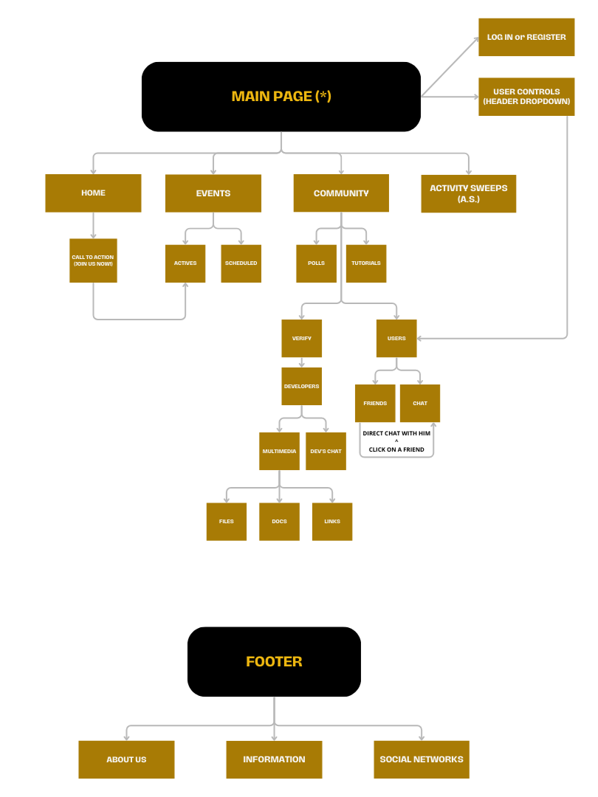**The navigation for the PHANTOM Central Hub has been designed to make everything easy to find while keeping the military and stealth vibe of the group. The menu is simple but organized, with clear names for each section so users can quickly get to what they need, like events, announcements, or community forums. The development team thought about the number of options, their order, and how deep the submenus should go, so it’s not so overwhelming but still has all the important stuff right where it belongs.**

**According to the navigation map, these are the links that are shown:**

* + **HOME: This is the home page. You can access it through the link in the header or by clicking on the logo located at the top left of the page. This page stores all announcements made by higher ranks.**
* **CALL TO ACTION (JOIN US NOW!): This button link is located at the end of each announcement on the home page. It directs users to an event currently happening on the Active Events page, allowing them to join.**
  + **EVENTS: This is a header menu dropdown that includes the following two pages:**
* **ACTIVES: This link is part of the dropdown under "EVENTS" in the header. You can access it by hovering your mouse or clicking on the "EVENTS" text. This will open the dropdown menu with the option to access the active events page, which is used to join ongoing events.**
* **SCHEDULED: Like "ACTIVES," this link is in the dropdown under "EVENTS." It provides access to the scheduled events page, where users can set reminders for upcoming events.**
  + **COMMUNITY: This header dropdown includes the following pages:**
* **POLLS: This link is found in the dropdown under "COMMUNITY." Users can access it by hovering over or clicking on the "COMMUNITY" text. The polls page allows users to vote on various polls.**
* **TUTORIALS: Like "POLLS," this link is part of the "COMMUNITY" dropdown. It leads to a page where users can learn tactics, guides about the roleplay game, and other tutorials created by trusted users.**
* **DEVELOPERS: This link is in the "COMMUNITY" dropdown but behaves differently. Clicking it opens a form for users to verify their credentials as developers. Verified developers can access a page with tools such as multimedia for projects, developer forums, bug reports, and feedback forms for maintaining the game.**
* **USERS: This link is also located in the "COMMUNITY" dropdown. It leads to a forum-like page where users can chat with friends, create private conversations, join general chats, edit their profiles, and view their P.R.A.S. achievements.**
  + **ACTIVITY SWEEPS: This page can be accessed through a link in the top-right header. It displays weekly stats for all users and highlights the top three performers in specific categories.**
  + **LOG IN and REGISTER: These options are visible only on the landing page, both in the header dropdown and directly on the page. They allow users to create an account linked to their Roblox profile or log in to an existing account to join the community.**
  + **HEADER DROPDOWN for the USER: After logging in, the header dropdown displays the user’s profile picture and name. Clicking on the dropdown arrow displays the profile and the settings and controls that if user click on them, it will provide access to the profile page, where users can manage their account and view their P.R.A.S. achievements.**
  + **ABOUT US: This link is in the footer and leads to a page explaining more about the Phantom roleplay group, the game map, and their communication server.**
  + **INFORMATION: This footer link directs users to a Google Drive folder containing documents and additional resources related to the roleplay group.**
  + **SOCIAL NETWORKS: These links in the footer lead users to the client’s social media accounts.**